ACKNOWLEDGEMENTS:
The author expresses deep appreciation and heartfelt thanks to Ken Edwards and Jack Schneider for their knowledge, sweat and toil, invaluable information, editing and review, “chauffeur” service and patience. This report could not have been completed without their dedication and assistance.
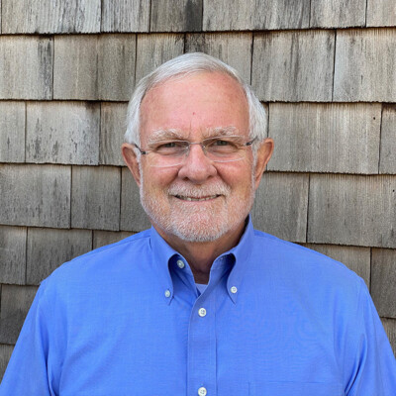

Ken Edwards – Trustee Jack Schneider – Land Trust Manager
