BRICKYARDS NORTH (Brickyard Trail) and BRICKYARDS SOUTH (Clay Pit Trail) PARCELS
F53 a/b/c are grass fuels and wildfire risk is lowered by mowing or prescribed burning. F54 is old grassy field that is invaded with woody plants and fire threats are low and there are no adjacent private structures.
The parcels in Brickyards North are timber models with low fire risk. The interior of Brickyards North is mostly non-burnable marsh and open water.
The outlying E09 and F49 parcels are low risk timbered models with patches of shrub.
Brickyard South is broken into three areas fuel model wise. Most of the interior as traversed by the Clay Pit trail is timbered woodlands with low wildfire risk (Parcels F44 and F39) . The southern portion is mostly parcel F33 which is made up of low risk Shrub (SH3) and has some old tree plantations with low risk timber fuels.
The area of E08, the old clay pit ravine, has continuous shrub fuels that increase in fuel loading as they climb the ravine up the slope to the SW corner of E08. This is a shrub fuel bed on 35% slope with a Northeast to East aspect. Although parcel is ranked High wildfire risk, but there are significant mitigating circumstances that reduce this danger. First off the East aspect is out of alignment both for high afternoon solar heating and for prevailing winds. The property surrounding the house at the top of this fuel bed is mowed lawn and a good fuel break to protect the house.

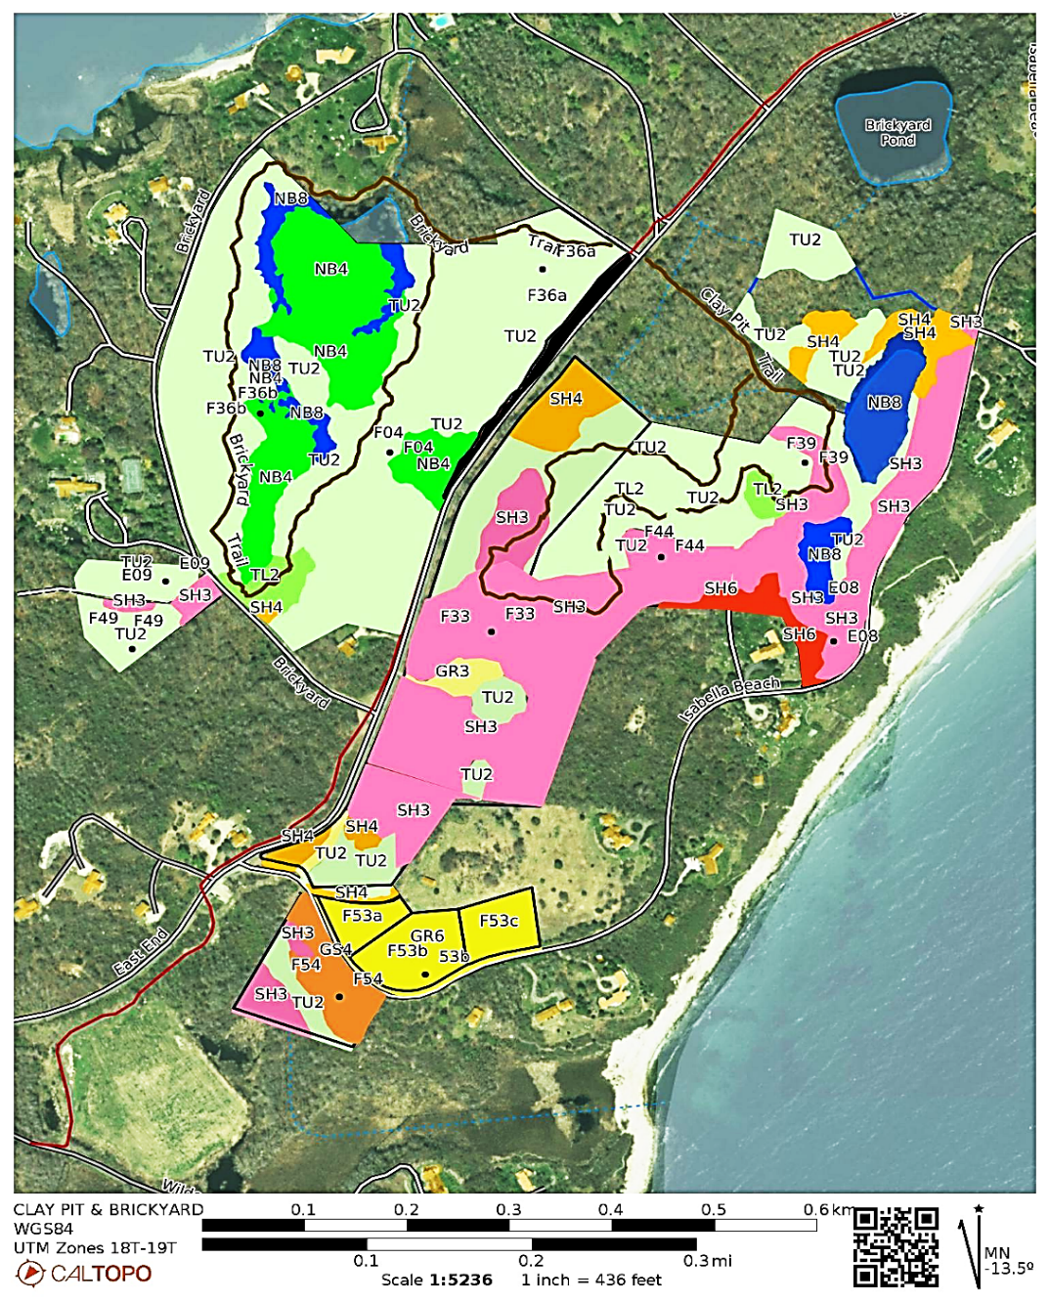
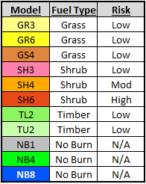
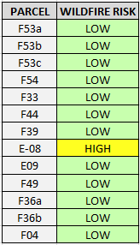
Fuel Models Present / Wildfire Risks

