CHOCOMOUNT
Parcel F34 is a large forest tract consisting of low risk timber fuels. There is also a marshy pepperbush dominated swamp in the SW portion that is non-burnable under all but extremely dry conditions (persistent drought).
Parcel 58a is primarily a low risk timber fuel model with a patch of low risk coarse grass fuel on the north end.
Parcel 58b is made up of low risk coarse grass fuels and the southwest quarter and low risk timber fuels on the southeast quarter. In the northern half there is a band of high risk Maritime Shrub that abuts a non-burnable beach, path and mowed lawn areas, which mitigates the wildfire risk to moderate.
Parcel F61 is a low wildfire risk shrub model with no immediately adjacent private infrastructure concerns.
Parcel F46 is a combination of 2/3 low risk timber fuels and 1/3 low risk shrubs.
Parcels E07a and E07b are mostly covered with low risk timber fuels. There is dense patch of high risk SH6 shrub fuel model in the NW corner of the steep mowed lawn that surrounds the house. This lawn and fire-resistant construction of the estate house make this parcel a low wildfire threat risk.
F62 is large parcel that is timbered shrub, a low wildfire risk model.
Parcel F43 has no improvements in the forested areas, and is the access to Chocomount Beach. This is a shrubby parcel with both moderate and high wildfire risk shrubs. The saving grace, wildfire wise, is that this shrubby parcel is isolated from adjacent infrastructure properties by a large mowed lawn and roads.

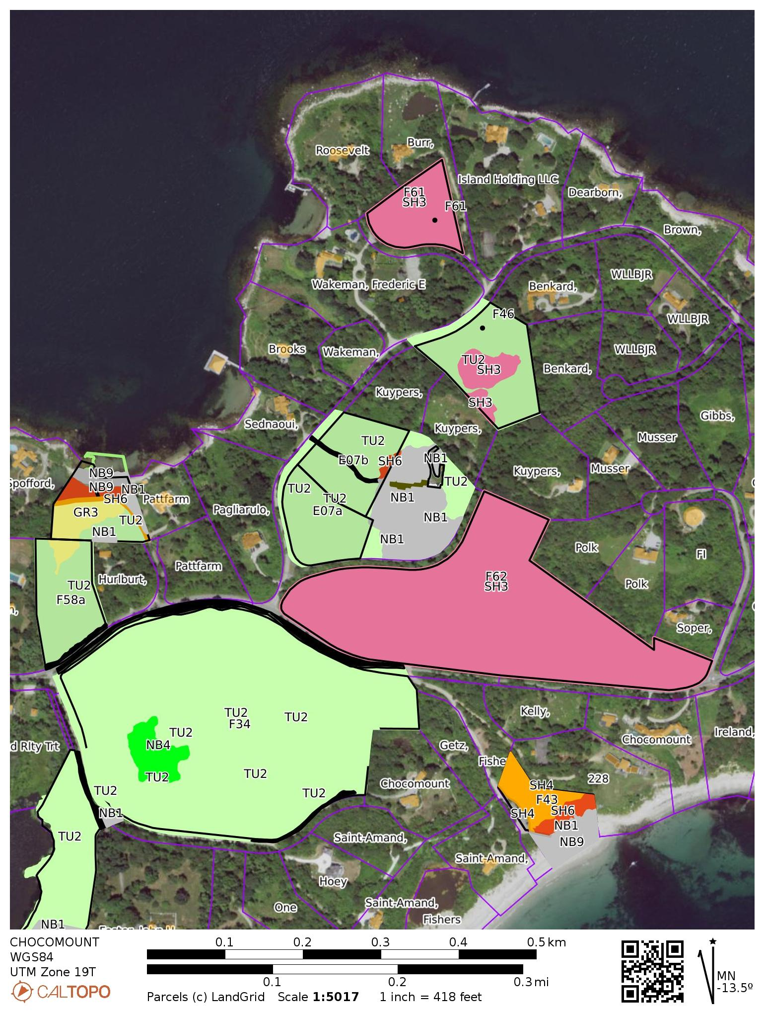
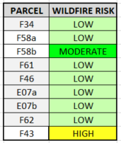
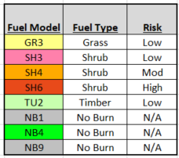

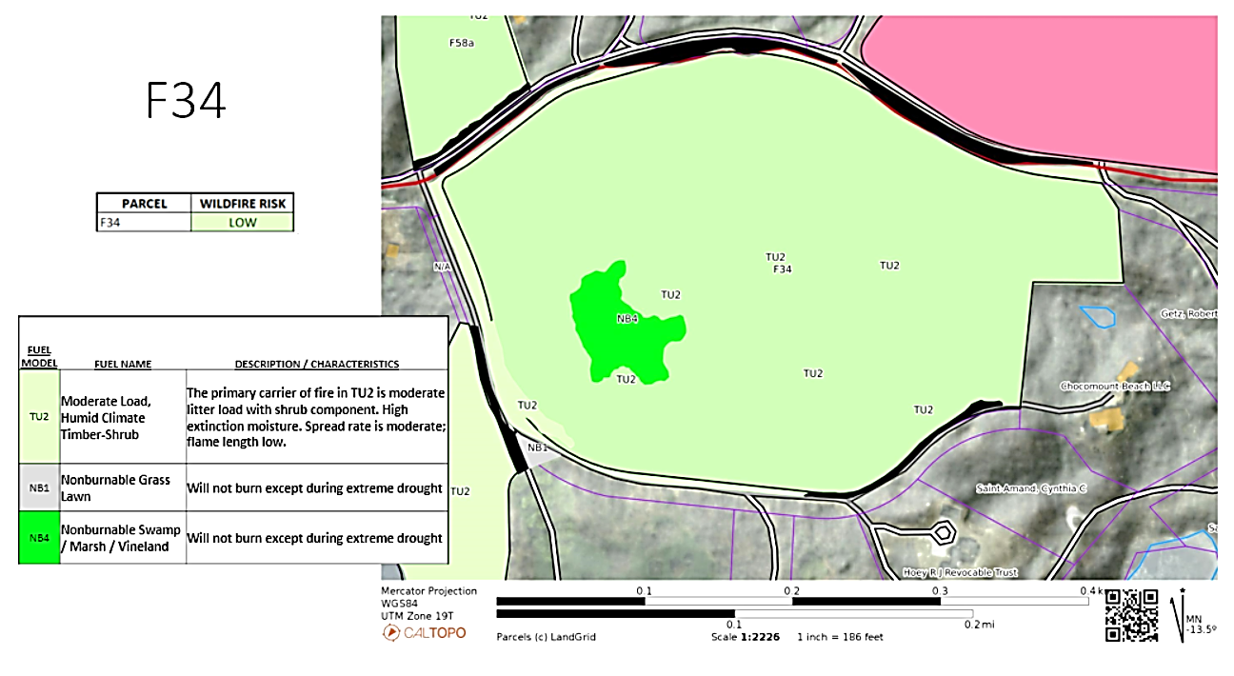

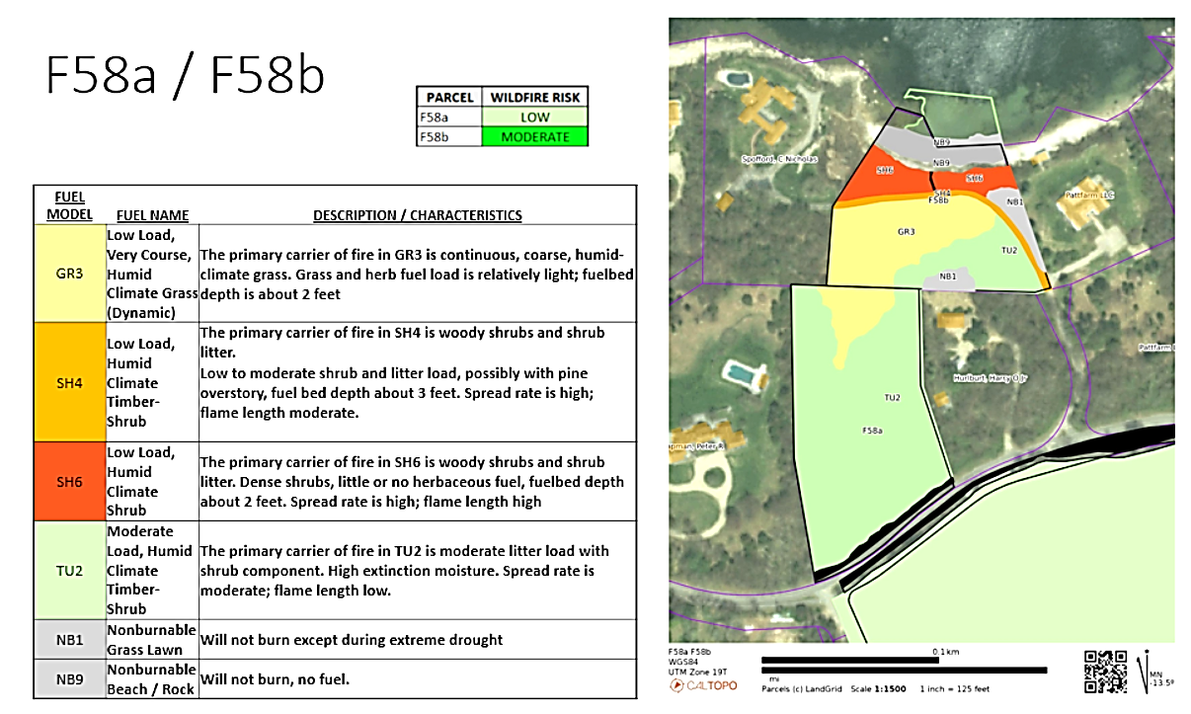

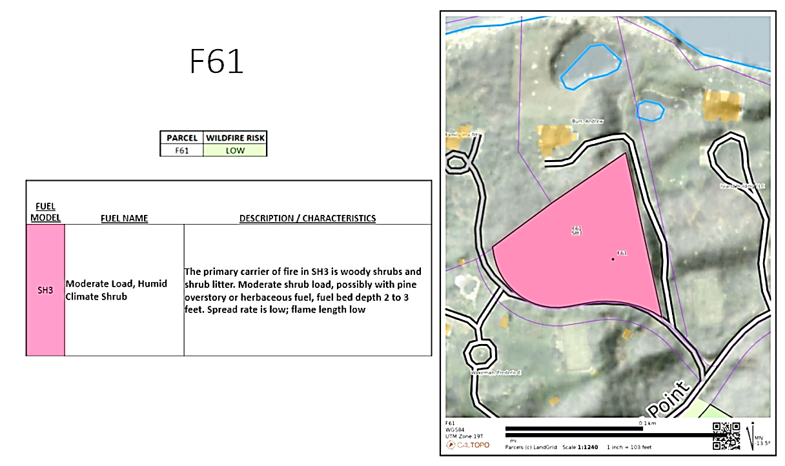
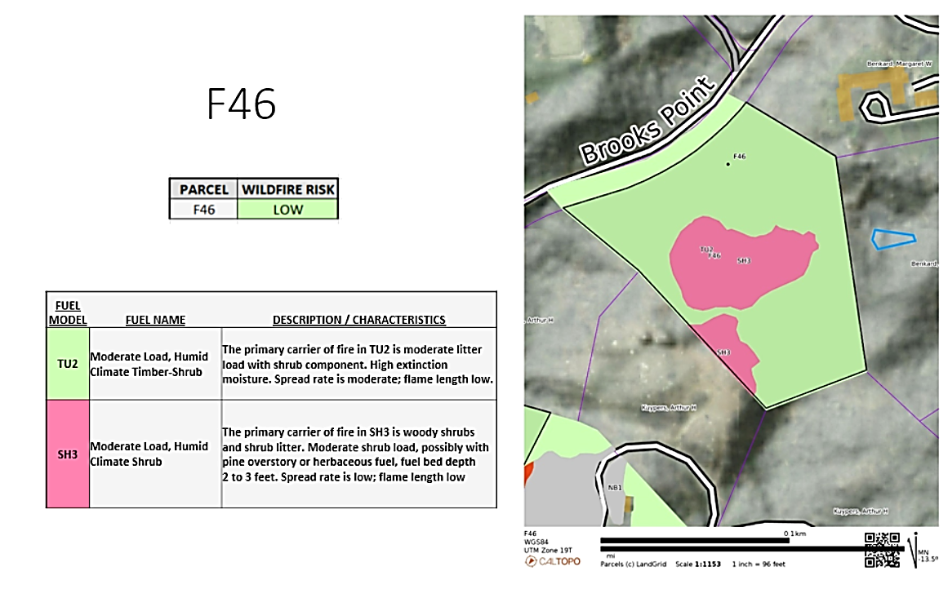

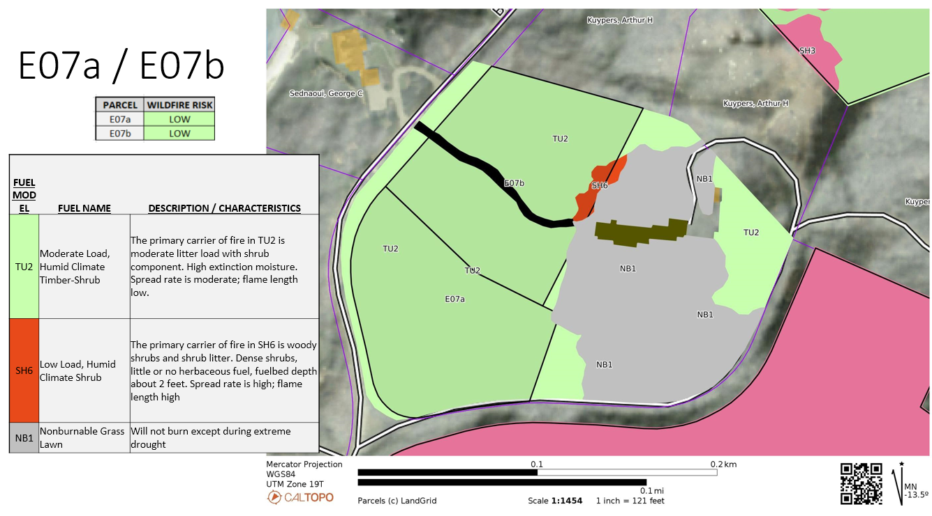

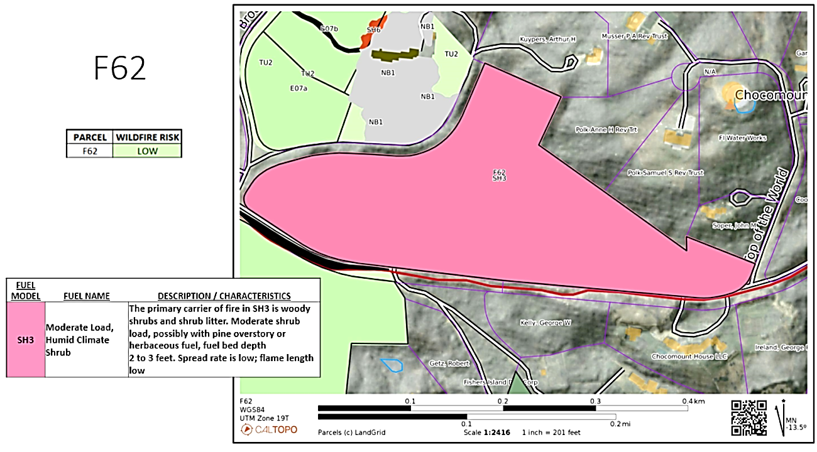

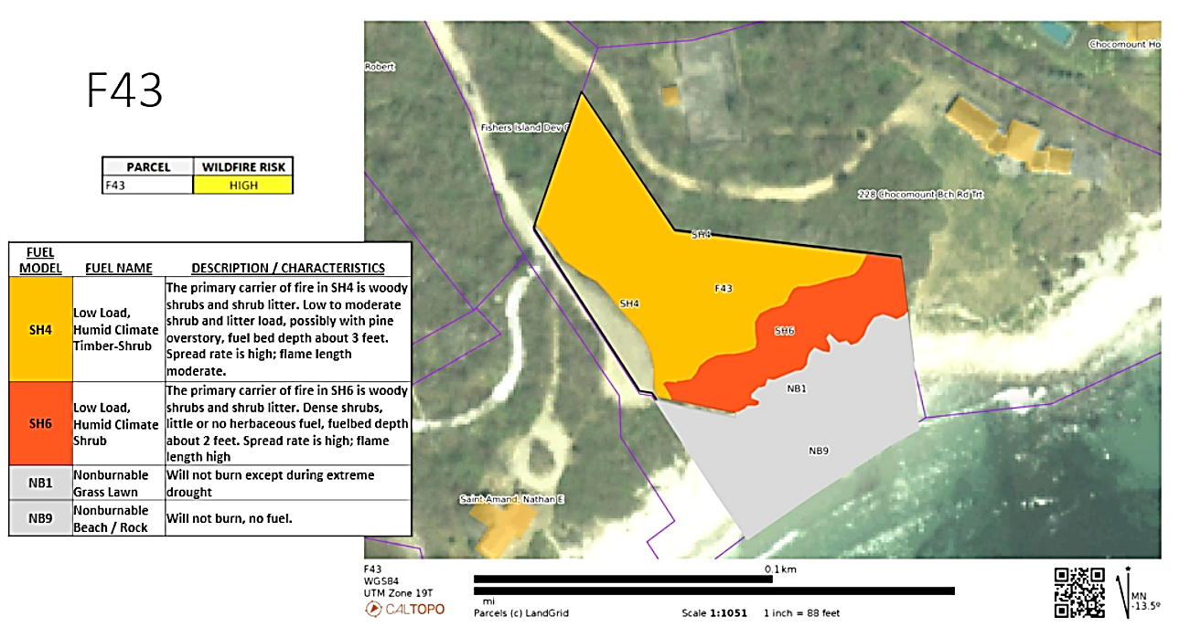
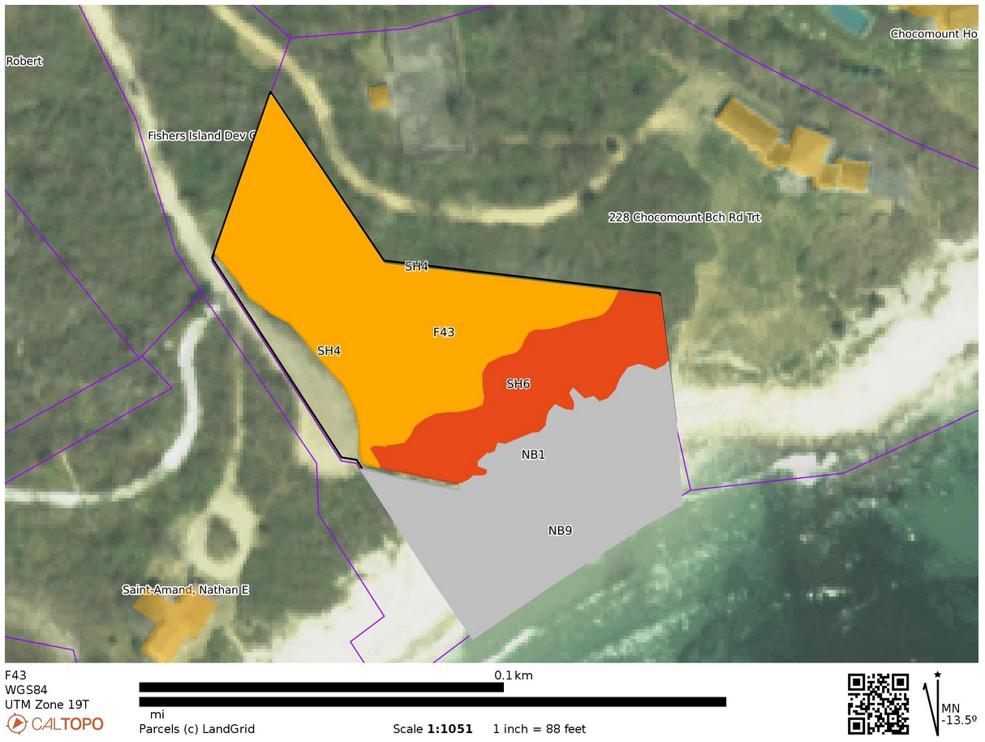
Parcel 43 is a shrubby fuel model and has a band of Maritime Shrub/Scrub paralleling the beach (the Red SH6 fuel model). This Scrub is a mixture of oak / cherry / saltbush and honeysuckle that may burn intensely under extremely dry circumstances. It has a very long (5-500 year) fire return interval. These fuels however are adjacent to buffers such as mowed lawns, beach and parking areas which mitigates wildfire concerns and lowers the risk to adjacent exposures.
F43

