West End
There are eight parcels in the West End. They vary from a remote beach peninsula with pockets of vegetation to downtown settings.
In F25, the peninsula, there is a mixture of grass and shrub fuels but they are very isolated and are surrounded by water and beach, ergo low wildfire risk.
The downtown parcels mostly consist of low fire activity timber fuels or open lawns. There are some pockets of shrub fuels, including the dense honeysuckle vines draped over shrubs in the northern portion of the Ferguson Museum property, F01 and F15. This is a case where the selected model may “over-predict” how wildfire would burn in the honeysuckle. Under extremely dry and windy conditions, when these shrubs are dormant and vines are dead and cured, these SH6 fuels may produce fire that meets the High risk definition. These patches are relatively small and are very accessible to fire suppression actions. As a result these conditions pose little threat to adjacent structures and private property and the overall wildfire risk rating for parcels F01 / F15 and F22 is Moderate.
The shrubby portion of F22, combined with the adjacent grass field, can pose a moderate threat under extremely dry conditions.

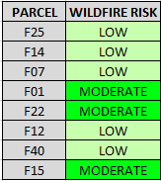
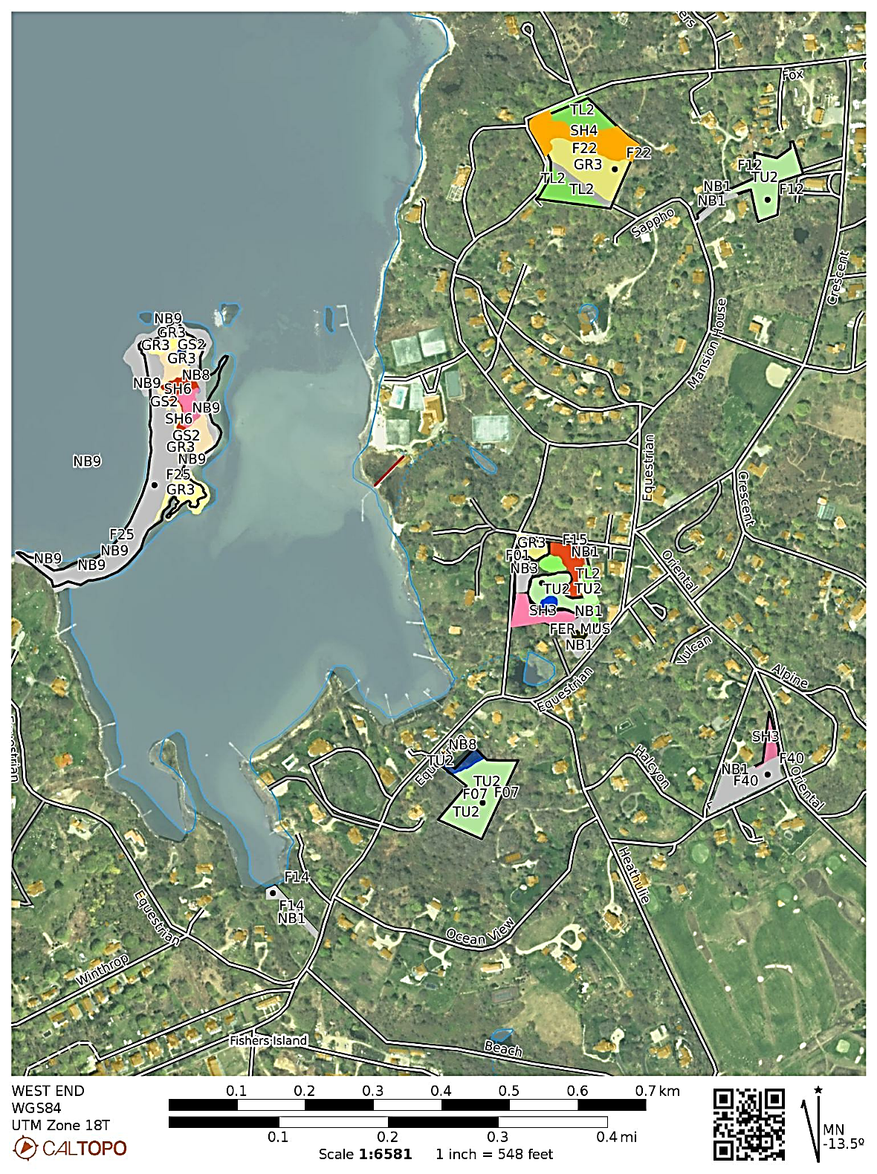
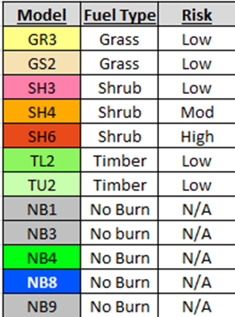
Fuel Models Present / Wildfire Risks

