WILDFIRE RISK ASSESSMENT OF OWNED OR OVERSEEN LAND PARCELS UNDER THE CARE OF
THE FERGUSON MUSUEM LAND TRUST, FISHERS ISLAND NEW YORK
Conducted by Robert A. Panko, Risky Business Incident Management LLC
April thru July 2025
Executive Summary
Based upon the very active fall wildfire season in the Northeast United States that occurred in 2024, the Ferguson Museum Land Trust obtained the services of Robert (Bob) Panko of Risky Business Incident Management LLC to evaluate the wildland fire risk upon its land parcels on Fishers Island. The Land Trust requested an assessment of the overall risks of wildland fires occurring on these lands that could potentially put adjacent neighbors in harm’s way. This report is to complete a wildland fire assessment on these parcels.
These parcels are mostly natural landscapes, managed to conserve open space, provide recreational opportunities and maintain natural habitats. These parcels are scattered throughout Fishers Island, and are embedded adjacent to private lands and developed infrastructure.
A fuel model designation is a set of vegetative characteristics present on a site. In 2005 the interagency National Wildfire Coordinating Group (NWCG) published a series of Standard Fire Behavior Fuel Models that are used nationwide. There are 40 standard fuel models in this comprehensive series. The models characterize the predicted fire behavior from the vegetation present on site. Variables include the total fuel loading present expressed in tons/acre; the volatility of the plants in both live and dead conditions; the horizontal and vertical arrangement of these fuels; the continuity of the fuels present and the conditions under which the fuels will or not burn. While some models contain fuels that burn extremely hot and fast, others produce low intensity wildfires. The differences of the risks involved are significant and predictable and are key to the expected intensity of a wildfire on those grounds.
In 2023, under contract with the Land Trust, the NY Natural Heritage Program completed a two year inventory of rare plants and animals and mapped the natural communities of the Land Trust parcels on Fishers Island. Using this as base line data, each parcel was visited and each of its vegetative communities was classed into one of the standardized NWCG fuel models. This established a relative wildfire hazard risk for each parcel. This study was used extensively to verify vegetation, overall fuel conditions observed and as reference to plant species present for additional fire behavior characteristics research.
Using this system 18 different fuel models were identified as present on the FMLT parcels. Fourteen of those fuel models are models that produce low to moderate intensity fires, won’t burn or will only burn under very extreme and very persistent weather conditions. Four models are present that tend to produce high flame lengths and rapid fire spread. Mostly those sites were limited to marshes with Phragmites Reed Grass (Model GS8) and Maritime Shrub/Scrub (Model SH6) along beach fringes. The risks presented by them are low due to isolation and, to some extent, extremely low frequency of wildfires in their habitats. The other models with high rates of spread are grass models found primarily in the Middle Farms Flats Grasslands which are routinely mowed and/or prescribed burned.
Many of the FMLT parcels are heavily invaded by non-native plants, and many of these non-natives make up the majority of the existing fuels loads. These non-natives, such as Japanese Honeysuckle, were present in both Timber Understory, Timber-Shrub and Shrub models. Considerable research was conducted to determine how volatile plants such as Japanese Honeysuckle actually are. The results from various sources (written reports, on line materials such as the US Forest Service Fire Effects Information System and interviews with Northeastern US wildfire experts) are that these plants do not burn readily and only burn under significantly rare conditions. Saying that, the fire behavior expected for many of the designated models would be “over-predicted”. Simply put, the model predicts more intensive fire behavior than should be expected.
I make this point with an example. In the Pine Barrens of Long Island (Fishers Island generally is included in this forest type) a timbered area with a “Heath” huckleberry/blueberry understory might be modeled as a Low Load, Humid Climate Shrub (SH4) with a predicted high rate of fire spread and moderate flame lengths. The Heath huckleberry/blueberry understory is a pyrogenic fuel with chemical content that burns readily even when green/live. Here in these FMLT parcels labeled as SH4, the understory is highly composed of Honeysuckle and other invasives which are resistant to burning. Although it is still ranked an SH4 model (because of the physical structure) the fire behavior in these parcels is likely over-predicted by the model except under very rare, extremely dry and windy and dormant plant conditions.
For the most part the FMLT parcels are surrounded by estates and properties with wide lawns and otherwise open areas. This is defensible space that protects adjacent structures from wildfire risks. In all there is only one property, Easement 04 off Old Mallory Road, where some shrub clearing to create a defensible fuel break for a small outbuilding would be recommended if the landowner wishes to protect this structure in the event of a wildfire coming up from the ravine below.
There is little (or no) history of wildfire on Fishers Island. During the field work for this project no visible signs of past wildfires was found other than from the prescribed burning conducted over the years in Middle Farms Flats grasslands. There was no char on trees or other signs of past fires. Ken Edwards, a lifetime resident of Fishers Island and former Fishers Island Fire Department Fire Chief, could not recall any large wildfires or any incidents of Maritime Scrub burning in the coastal areas or other areas where it is present.
Many factors determine how a wildland tract of vegetation may burn. Vegetative fuels present is merely one factor. The amount of moisture present in wildland fuels on a daily basis determines whether or not fuels present are available to burn on a given day. The alignment of fire behavior factors such as wind, topography, temperature and humidity determine whether fire will burn passively or aggressively on any given day. Short and long term weather cycles impact these daily conditions creating conditions such as persistent drought that exacerbates these daily fuels conditions. Under extremely rare conditions almost any organic material in forests or range lands COULD burn, even mowed grass lawns. But these are rare events that come and go. The basic fuels remain on a tract of land and increase or decrease depending upon disturbances to that fuel bed.
Based on all of this, in summary, the results of this survey indicate that wildfire risks from the fuels present and expected for the next ten years on the FMLT parcels is low to moderate. The weather conditions / persistent drought experienced in the fall of 2024 in the Northeast US were unprecedented in recent history. Yet even under those conditions the likelihood of a large fast moving fire emanating from the FMLT parcels and posing a threat to adjacent private properties and infrastructure was extremely small.

Summary of Findings:
The fuel models used are from the National Wildfire Coordinating Group (NWCG) official publication of the Standard Fire Behavior Fuel Models: These forty models are standardized nationwide. These models are categorized by Grass Fuel Models, Shrub Fuel Models, Timber Fuel Models, Slash Fuel Models and Non-Burnable Fuel Models. Of these models six Grass models, three Shrub models, four Timber models and four “Non Burnable Models” were found in the FMLT parcels. That included a custom “Non-Burnable” model that was added to represent Willow Swamp / Pepperbush Swamp / Vineland and Shrubland thickets.
These models introduced in 2005 feature several models that are listed as Dynamic. This term describes that fuels will burn differently (or won’t burn) during different seasons. A simple example of that on Fishers Island is the Middle Farms Flats grasslands. In mid to late spring these dormant grass fuels are very capable of burning. By the end of May, however, these grasslands are in full vigor and are too green to burn. The “dynamic” fuels are labeled as such in the national set of Scott and Burgan models. What is noteworthy here, however, is that several additional fuel models found in the FMLT parcels may also be dynamic due to presence of invasive plants. A commonly occurring fuel model here is Moderate Load, Humid Climate Shrub – SH3. On Fishers Island this shrub component is mostly made up of Japanese Honeysuckle. SH3 is not a “dynamic” fuel model by definition, however it is felt that this model will burn when it is in dormant stage, but will not burn when it is in the full vigor of summer / early fall.

The following fuel models were found within the FMLT parcels:

FUEL MODEL | FUEL NAME | DESCRIPTION / CHARACTERISTICS
GR3 | Low Load, Very Course, Humid Climate Grass (Dynamic) | The primary carrier of fire in GR3 is continuous, coarse, humid-climate grass. Grass and herb fuel load is relatively light; fuelbed depth is about 2 feet. This is the most common grass model found outside of the Middle Farm Flats grasslands in the FMLT parcels. This is a seasonally dynamic model that will not burn when fully green (generally mid –May through September).
GR6 | Moderate Load, Humid Climate Grass (Dynamic) | The primary carrier of fire in GR6 is continuous humid-climate grass. This grass model makes up most of the eastern portion of the Middle Farm grasslands. This is a seasonally dynamic model that will not burn when fully green (generally mid –May through September).
GR8 | High Load, Very Coarse, Humid Climate Grass (Dynamic) | In the FMLT parcels this model consists solely of Phragmites Reed Grass in marshes and pond margins. The primary carrier of fire in GR8 is continuous, very coarse, humid-climate grass. Load and depth are greater than GR6. Spread rate and flame length can be extreme if grass is fully cured. This is a seasonally dynamic model that will not burn when fully green (June-September).
GS2 | Moderate Load, Dry Climate Grass-Shrub (Dynamic) | The primary carrier of fire in GS2 is grass and shrubs combined. Shrubs are 1 to 3 feet high, grass load is moderate. Spread rate is high; flame length moderate. In this study this model is only used for Salt Marsh and Salt Scrub habitats. Although a “dry climate” model, it was chosen as best match for these habitats in fuel loading / composition / continuity. This is a seasonally dynamic model that will not burn when fully green (June-September).
GS3 | Moderate Load, Humid Climate Grass-Shrub (Dynamic) | The primary carrier of fire in GS3 is grass and shrubs combined. Moderate grass/shrub load, average grass/shrub depth less than 2 feet. Spread rate is high; flame length moderate. Moisture of extinction is high. This model is only found in the Middle Farm Flats grasslands. This is a seasonally dynamic model that will not burn when fully green (generally mid –May through September).
GS4 | High Load, Humid Climate Grass-Shrub (Dynamic) | The primary carrier of fire in GS4 is grass and shrubs combined. Heavy grass/shrub load, depth greater than 2 feet. Spread rate high; flame length very high. This model was only found in a portion of the grassland in F54. This is a seasonally dynamic model that will not burn when fully green (June-September).
SH3 | Moderate Load, Humid Climate Shrub | The primary carrier of fire in SH3 is woody shrubs and shrub litter. Moderate shrub load, possibly with pine / hardwood overstory or herbaceous fuel, fuel bed depth 2 to 3 feet. Spread rate is low; flame length low. This was a pretty common model in this study and was chosen to for numerous woodlands that are invaded by non-native shrubs and vines as an understory. Fire behavior is likely over-predicated by using this model, due to fire resistance of these non-natives. Although not listed as a “dynamic” model higher flame lengths and rates of spread may occur when these shrubs are dormant and the vines/shrubs now become available to burn.
SH4 | Low Load, Humid Climate Timber-Shrub | The primary carrier of fire in SH4 is woody shrubs and shrub litter. Low to moderate shrub and litter load, possibly with pine overstory, fuel bed depth about 3 feet. Spread rate is high; flame length moderate. This model was selected in this study for sites that had higher fuel loading than SH3. Fire behavior is likely over-predicated by using this model, due to resistance to fire of these non-natives. Although not listed as a “dynamic” model higher flame lengths and rates of spread may occur when these vines/shrubs are dormant and available to burn.
SH6 | Low Load, Humid Climate Shrub | The primary carrier of fire in SH6 is woody shrubs and shrub litter. Dense shrubs, little or no herbaceous fuel, fuelbed depth about 2 feet. Spread rate is high; flame length high. This model was chosen in this study to represent areas of Maritime Shrub / Maritime Scrub which were mostly dense shrub patches of invasive Japanese Rose mixed with buckthorn, honeysuckle and some oak and cherry. SH6 is usually a hot burning, fast moving fuel model. In this case it is felt that these scrub patches will only burn under extremely dry conditions with strong winds in upslope alignment. This model was also used in some instances with very high shrub fuel loading other than Maritime Shrub/Scrub.
TL2 | Low Load Broadleaf Litter | The primary carrier of fire in TL2 is broadleaf (hardwood) litter. Low  load, compact broadleaf litter. Spread rate is very low; flame length very low. This model was found very infrequently in this study.
TL4 | Small downed logs | This model was found only on one property, an easement, where some timber had been cut and left of the ground. The primary carrier of fire in TL4 is moderate load of fine litter and coarse  fuels. Includes small diameter downed logs. Spread rate is low; flame length low.
TU2 | Moderate Load, Humid Climate Timber-Shrub |  | This is the most prevalent fuel model found in this study, which is not unusual as it is a very common northeastern hardwood fuel model. The primary carrier of fire in TU2 is moderate litter load with shrub component. High moisture of extinction. Spread rate is moderate; flame length low.
TU3 | Moderate Load, Humid Climate Timber-Grass-Shrub (Dynamic) |  | This model was found in only 3 sites in this study. The primary carrier of fire in TU3 is moderate forest litter with grass and shrub components. Extinction moisture is high. Spread rate is high; flame length  moderate.
NB1 | Nonburnable Urban/ Suburban areas with Grass Lawns. |  | Will not burn except during extreme drought. For grass lawn to carry fire it must be completed desiccated and dry. Grass lawns are used to create defensible space around structures in urban / suburban and rural settings.
NB3 | Nonburnable Agriculture |  | Will not burn if maintained under agricultural use. The only site designated with this model is a small portion of the Ferguson Museum grounds F01.
NB4 | Nonburnable Swamp / Marsh / Vineland |  | Will not burn except during extreme drought. This is not one of the “standard” 40 models, but was added to use in this study. This model reflects areas that will not carry fire except under extremely persistent dry conditions. These are generally willow and/or pepperbush marshes and vinelands often with standing water at the surface. Under almost all conditions these fuels would represent firebreaks in the wildland.
NB8 | Nonburnable Lake / Open Water |  | Will not burn
NB9 | Nonburnable Beach / Rock |  | Will not burn due to exposed rock / sand / gravel and extremely sparse fuels.
Table 1 Fuel Model Codes, Name and Description
Fuels and Risks by Contiguous Parcel Listing
The following are maps and wildfire risk findings listed using Contiguous Parcel groupings. Each page has a description of the fuels and risks, displays a map of the group of parcels, and has a table showing the relative wildfire risk for each parcel and a table of the fuel models present in this group of parcels.
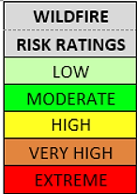
The values of the wildfire risk ratings per parcel are coded as follows in Table 2
LOW | Surface fires with low flame lengths, moderate rate of spread and no spotting. Fires pose little or no threats to directly adjacent properties.
MODERATE | Surface fires with moderate flame lengths, moderate rate of spread & minimal spotting. Fires pose a minor threat to directly adjacent woodlands/grasslands or directly adjacent buildings and are easily protected.
HIGH | Surface fires with high flame length (8’ or more), high rate of spread (300’/hour or more). Sustained fire in the shrub layer with single tree torching. Spotting 20’ or more. Threats exist only to immediately adjacent properties.
VERY HIGH | Surface fires with group torching, flame length very high, rate of spread very high and spotting 200’ of more. Threats exist to adjacent properties.
EXTREME | Fire is being carried in shrub layer or tree crowns independent of surface fire. Flame lengths very high, rate of spread very high. Spotting ¼ mile or more creating significant threats to adjacent properties.
Description of Risk Ratings:
Table 2 Risk Ratings
West End
There are eight parcels in the West End. They vary from a remote beach peninsula with pockets of vegetation to downtown settings. In F25, the peninsula, there is a mixture of grass and shrub fuels but they are very isolated and are surrounded by water and beach, ergo low wildfire risk. The downtown parcels mostly consist of low fire activity timber fuels or open lawns. There are some pockets of shrub fuels, including the dense honeysuckle vines draped over shrubs in the northern portion of the Ferguson Museum property, F01 and F15. This is a case where the selected model may “over-predict” how wildfire would burn in the honeysuckle. Under extremely dry and windy conditions, when these shrubs are dormant and vines are dead and cured, these SH6 fuels may produce fire that meets the High risk definition. These patches are relatively small and are very accessible to fire suppression actions. As a result these conditions pose little threat to adjacent structures and private property and the overall wildfire risk rating for parcels F01 / F15 and F22 is Moderate. The shrubby portion of F22, combined with the adjacent grass field, can pose a moderate threat under extremely dry conditions.
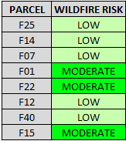
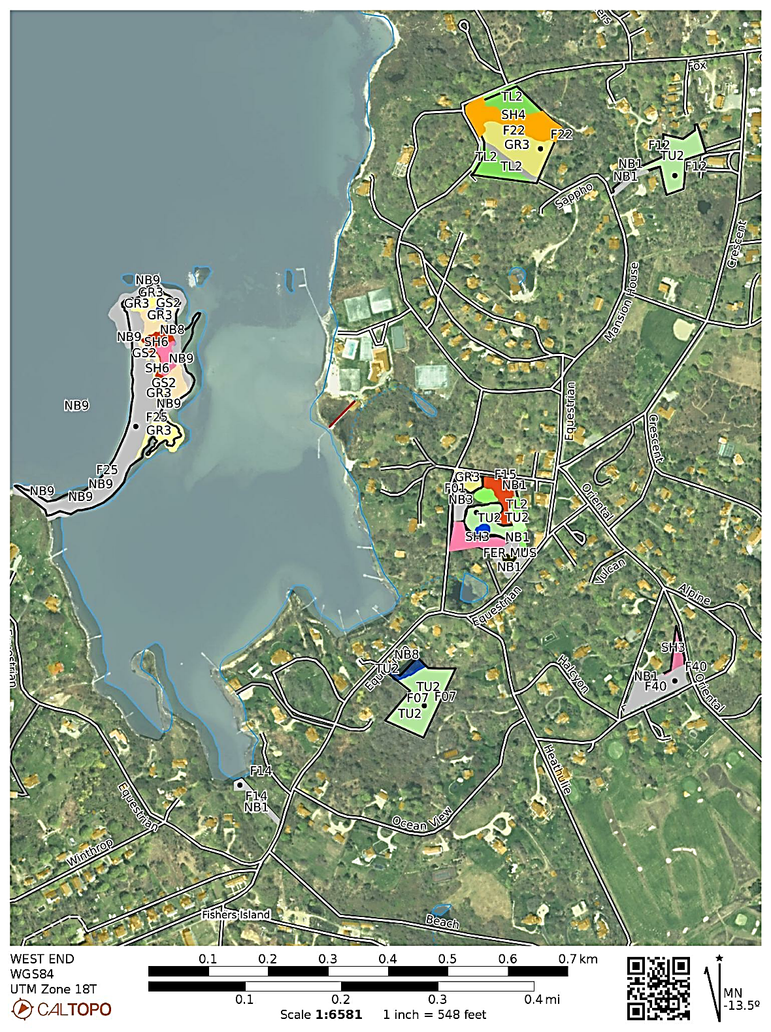
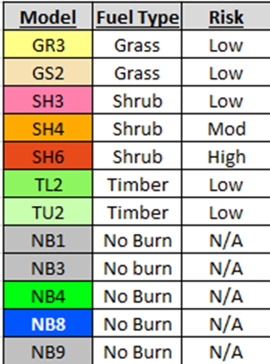
and a shrubby portion of F22.
Fuel Models Present / Wildfire Risks

BRICKYARDS NORTH (Brickyard Trail) and BRICKYARDS SOUTH (Clay Pit Trail) PARCELS
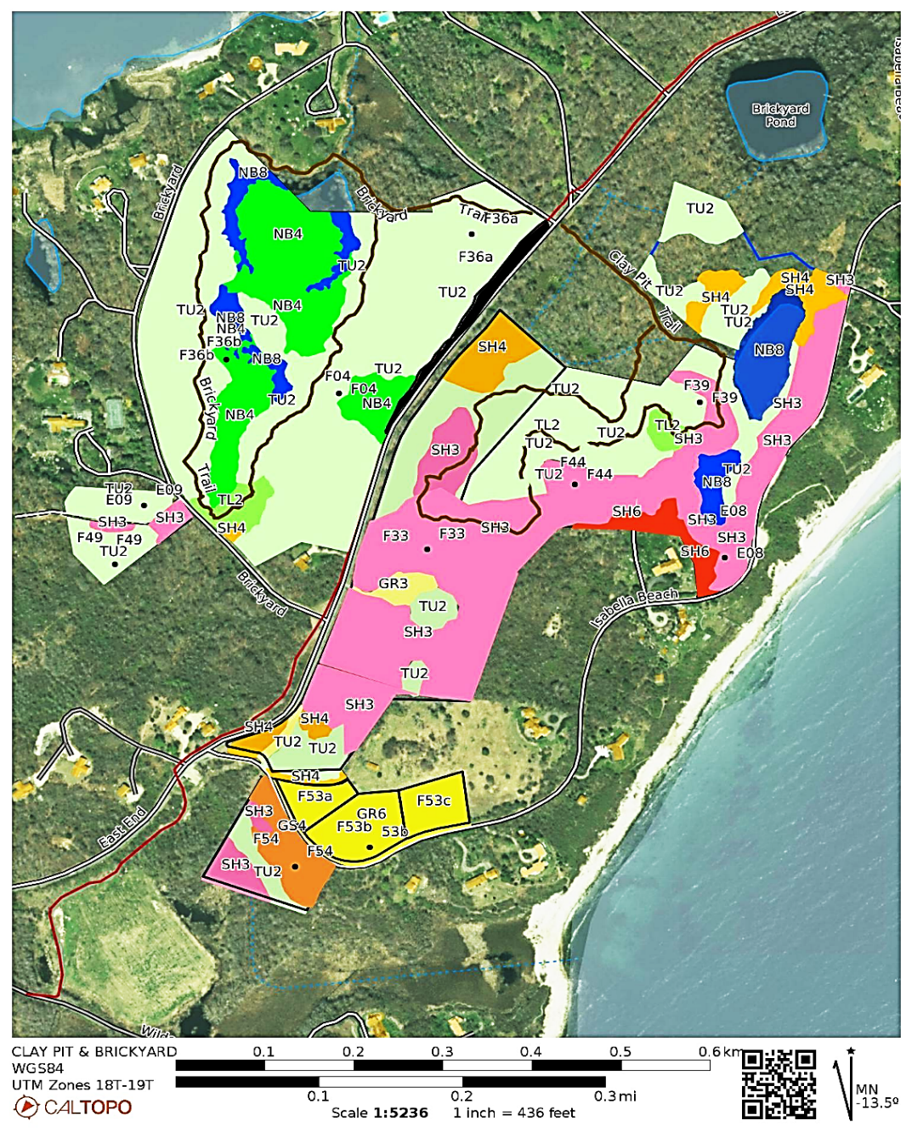
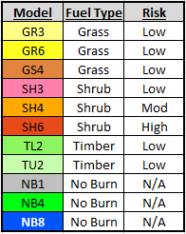
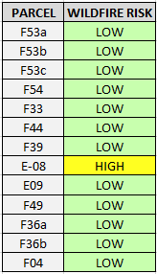
F53 a/b/c are grass fuels and wildfire risk is lowered by mowing or prescribed burning. F54 is old grassy field that is invaded with woody plants and fire threats are low and there are no adjacent private structures. The parcels in Brickyards North are timber models with low fire risk. The interior of Brickyards North is mostly non-burnable marsh and open water. The outlying E09 and F49 parcels are timbered models with patches of shrub. Brickyard South is broken into three areas fuel model wise. Most of the interior as traversed by the Clay Pit trail is timbered woodlands with low fire behavior risk. The southern portion is mostly parcel F33 which is made up of low risk Shrub (SH3) and has some old tree plantations with low risk timber fuels. The area of E08, the old clay pit ravine, has continuous shrub fuels that increase in fuel loading as they climb the ravine up the slope to the SW corner of E08. This is a shrub fuel bed on 35% slope with a Northeast to East aspect. Although parcel is ranked High wildfire risk, but there are significant mitigating circumstances that reduce this danger. First off the East aspect is out of alignment both for high afternoon solar heating and for prevailing winds. The property surrounding the house at the top of this fuel bed is mowed lawn and a good fuel break to protect the house.
Fuel Models Present / Wildfire Risks

BARLOW POND SOUTH
The fuel models on parcel F06 are low risk timbered fuels and low risk shrubs that make up marsh surrounding open water. Parcel F28 is 50% low risk timber fuels and 50% moderate shrub fuels with no structures adjoining the shrub fuels which reduces wildfire risk to adjacent properties. The E04 parcel consists of a steep ravine with a Southeast aspect. The toe of this slope is at the beach on Block Island Sound. Above the beach to the top of the bluff at the head of the ravine are continuous shrub fuels including both Maritime Shrub/Scrub and Successional Shrub forest. These shrub models are rated as High risk. The NE corner of this parcel, at the top of the slope, is a low risk timbered tree plantation.
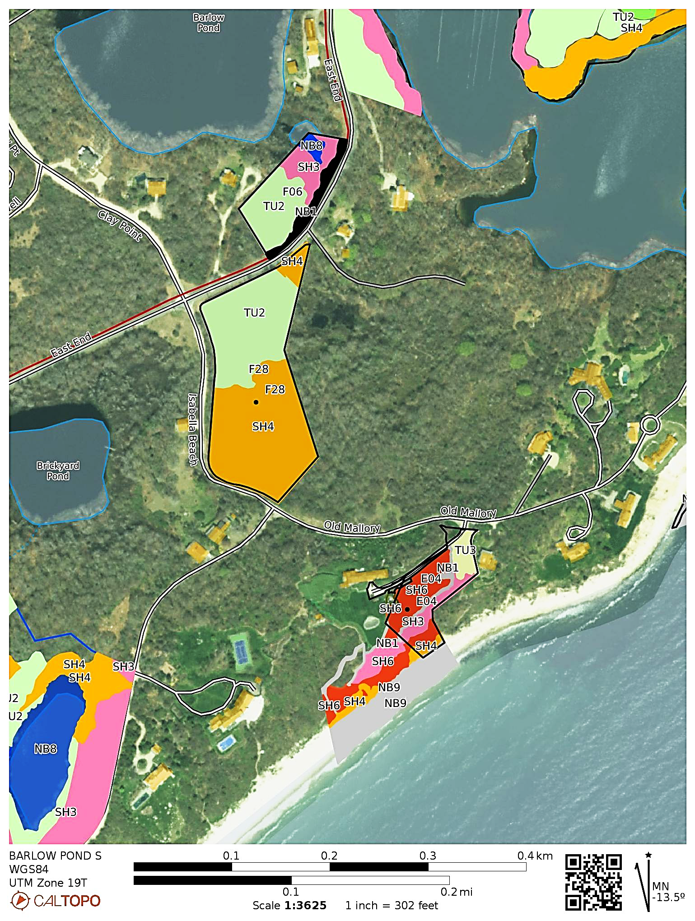
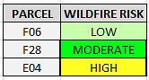
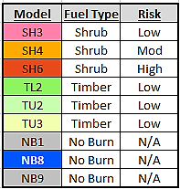
A small structure (an art studio) is perched on the edge of this ravine at the top of this steep SE aspect and is embedded in dense shrub fuels. The landowner should decide if some clearing to create a fire break around the structure is merited, or, since this is not a very expensive structure just accept risk of loss due to a possible wildfire. As mentioned before in this report fire behavior predicted in these shrub fuels may be over-predicted by the model due to reluctance of the Maritime Shrub / Scrub vegetation to burn unless under rare and extreme conditions. The large mansion on the main property is not at risk from fire. Further details on E04 are included in the single parcel sheet appendix.

Barlow Pond North, Island Pond and Clay Point Road
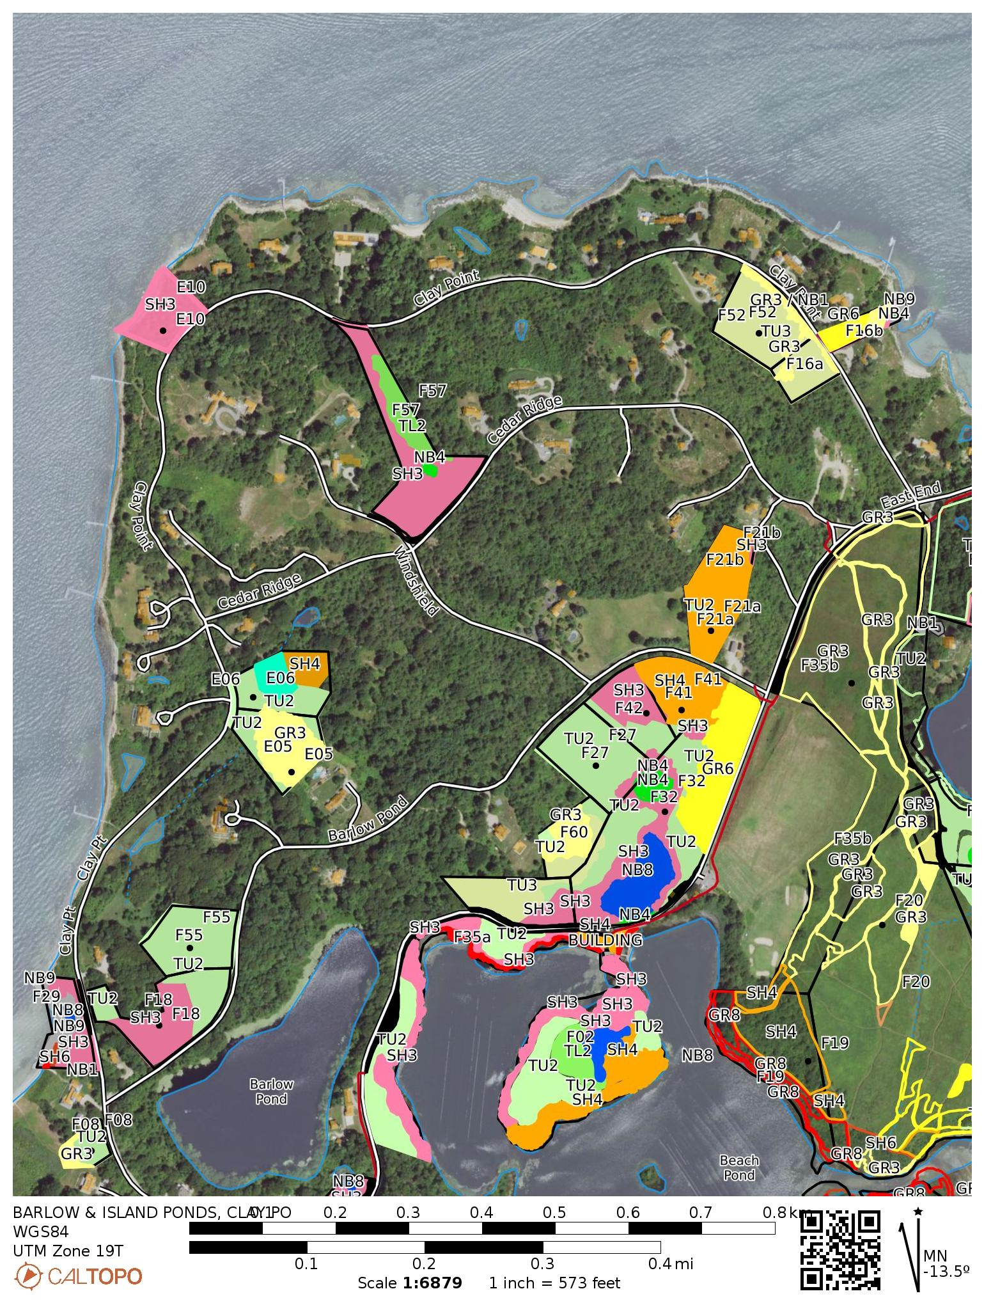
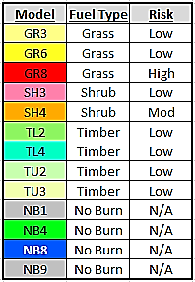
The fuel models on parcel F08 are low risk timbered and grass fuels. F29 has an isolated patch of phragmities that is no risk due to location while most of the parcel is non-burnable. F18 / F55 / F35a / F57 / E10 all are mixed woodlands with low risk timber and low risk shrub fuels. E06 is mostly low risk timber fuels with a small patch of moderate risk shrub, but there are no private exposures of concern. E05 is a combination of low risk timber and low risk grassland. F52 and F16a are low risk timber and patches of low risk grasses. F16b is mostly low risk grasses with band of shrubs adjacent to non-burnable beach and marsh. F21a & F21b are both timbered with moderate shrub understory. The Middle Farms North parcels are timbered with interior marsh and open water that are surrounded by low risk shrub fuels. F32 has a 2.5 acre field of heavy grass that can be kept as low risk with routine prescribed burning or mowing. F02 is mostly the island in the Island Pond and although it has some shrubby fuels there is no risk of wildfire escaping the island.
MIDDLE FARMS, TREASURE POND AND BARRIER BEACH
The Middle Farms Flats parcels (F19/F20 /F35b/E01/E03) consist of grass fuels including grass shrub fuels in the grassland itself. These fuels are low risk when they are burned or mowed. East of the grassland the parcels have low risk timber fuels. West and south of the grassland is a mixture of low risk timber, moderate risk shrub fuels and high risk phragmites that basically hug shorelines of Island Pond. Since these fuels are placed between open water and the low risk maintained field they present low wildfire risk.
Barrier Beach parcels (F38/F38b) have both abundant Maritime Shrub/Scrub and phragmites grasses but are surrounded by water. F03 fuels are limited to a band of high risk Maritime Shrub between the waters of Island Pond and Block Island Sound. This band of Maritime Shrub continues east of the property line of Parcel F03 onto adjacent private lands. There is no history of these Maritime Shrub/Scrub habitats burning on Fishers Island, however these fuels may have a very long fire return interval (200 or more years). Further details on F03 are included in the single parcel sheet appendix.
The parcels north and south of Middle Farms Pond (north are F63/Town Owned/F17/F10; south are F11/F09/F24/F23) are generally low risk timber models with some low risk shrub areas and non-burnable wet marsh habitats. Along the southern edge of F23 there is a maritime bluff band of fuels that runs east-west. This feature contains a good mix of shrub/scrub plants that will burn intensely under very rare conditions. The good news is that this band is hemmed in by low risk timber fuels, unburnable marsh thicket and non-burnable rock beaches. So the wildfire risk is low.
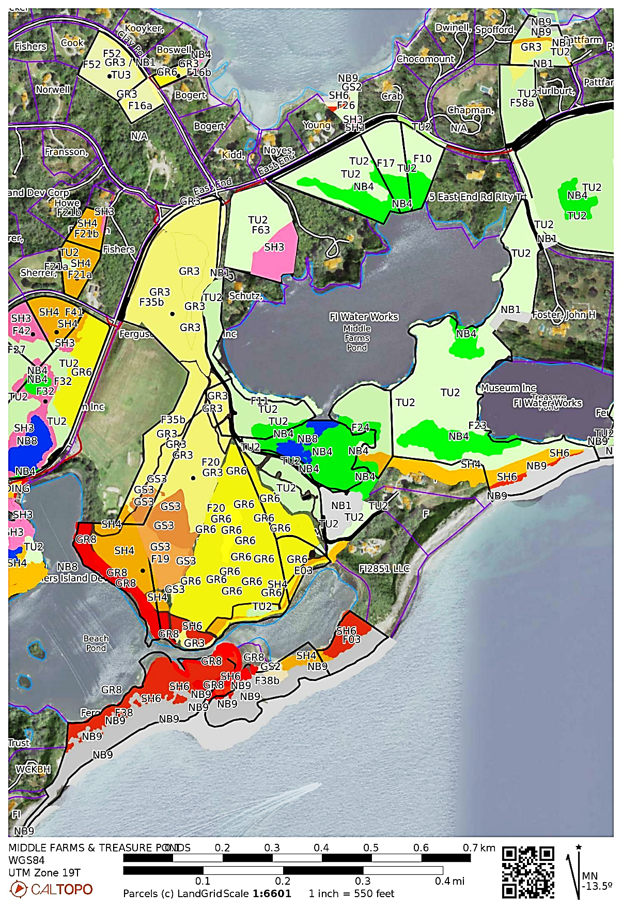
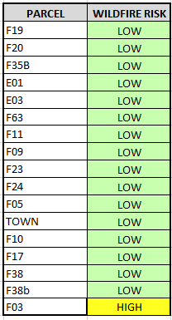

CHOCOMOUNT
Parcel F34 is a large forest tract consisting of low risk timber fuels. There is also a marshy pepperbush dominated swamp in the SW portion that is non-burnable under all but extremely dry conditions (persistent drought). Parcel 58a is primarily a low risk timber fuel model with a patch of low risk coarse grass fuel on the north end. Parcel 58b is made up of low risk coarse grass fuels and the southwest quarter and low risk timber fuels on the southeast quarter. In the northern half there is a band of high risk Maritime Shrub that abuts a non-burnable beach and path which mitigates the wildfire risk to moderate.

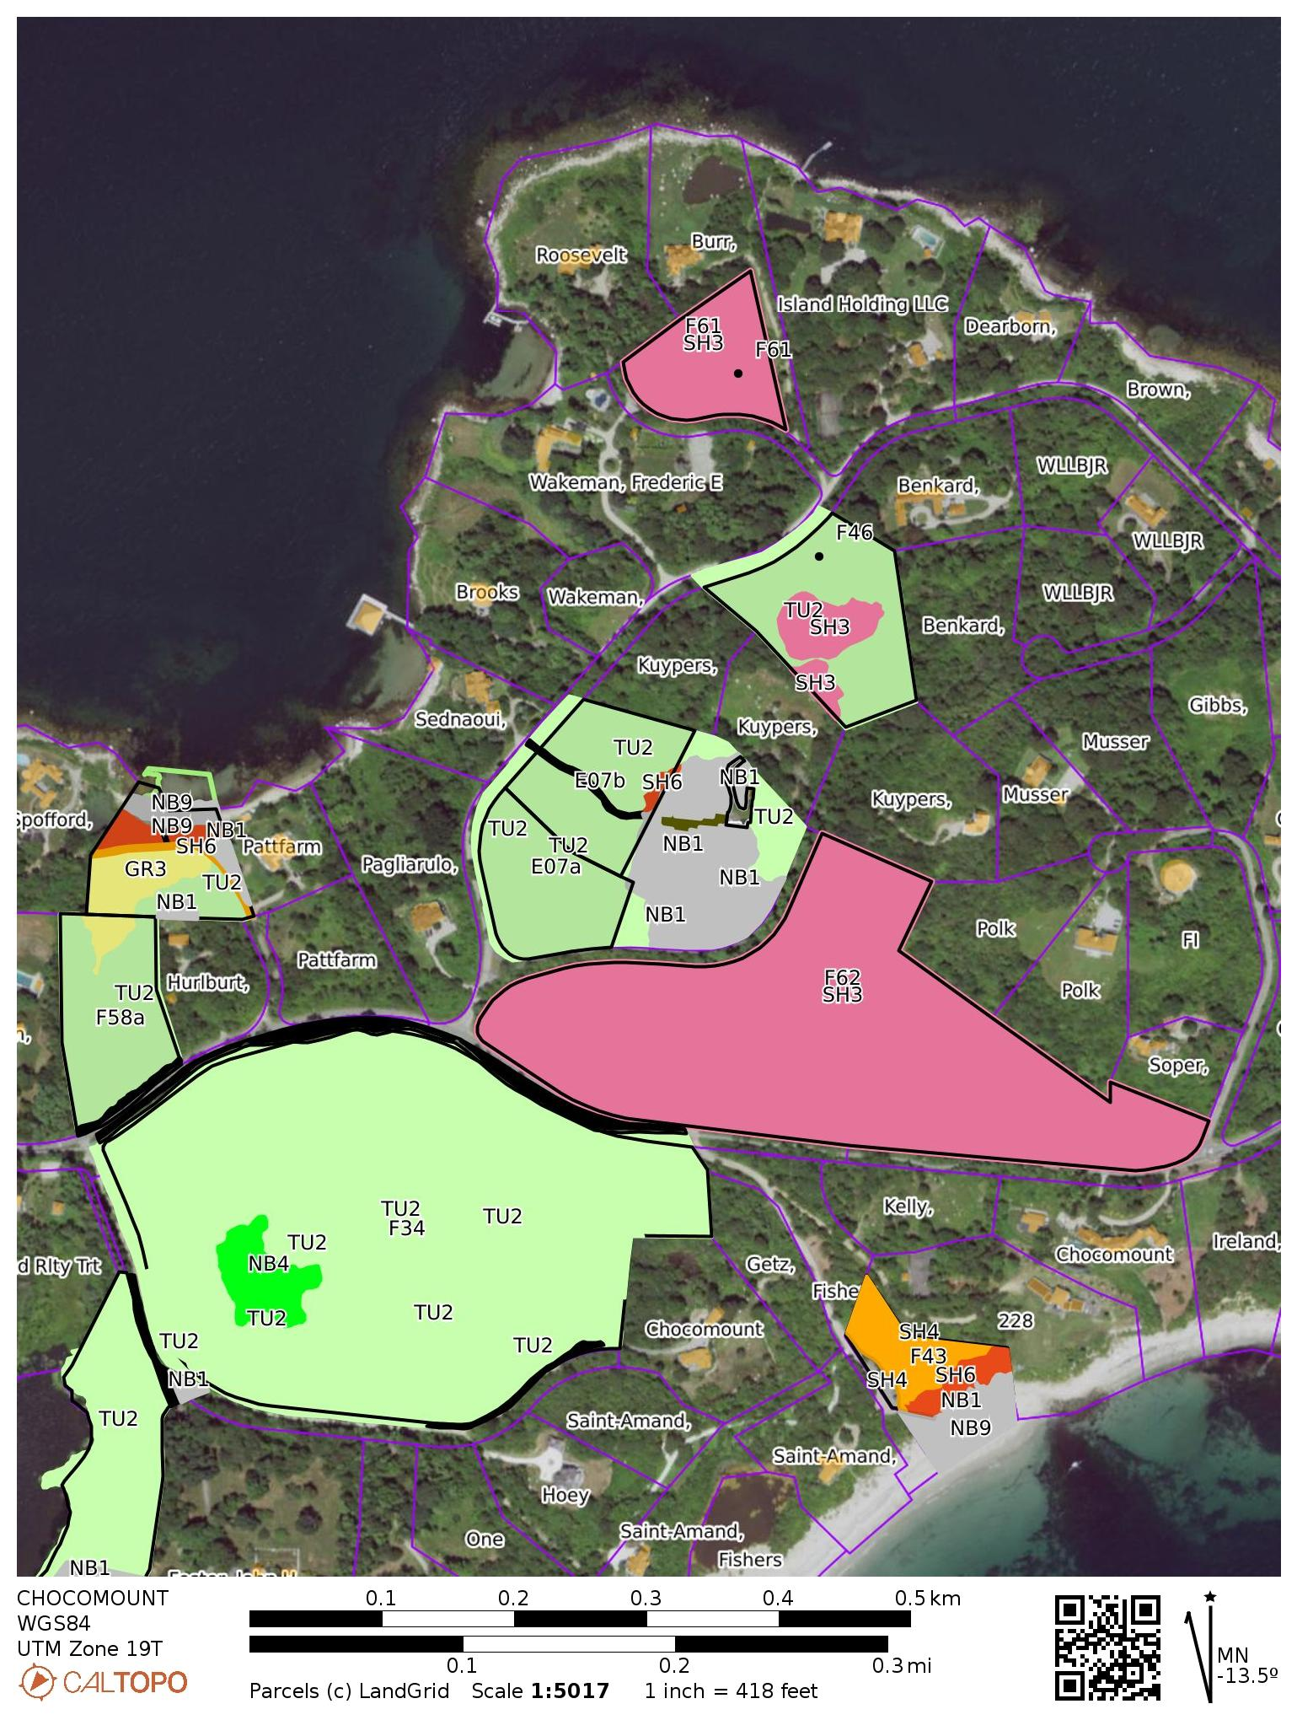
CHOCOMOUNT BEACH AND COASTAL POND
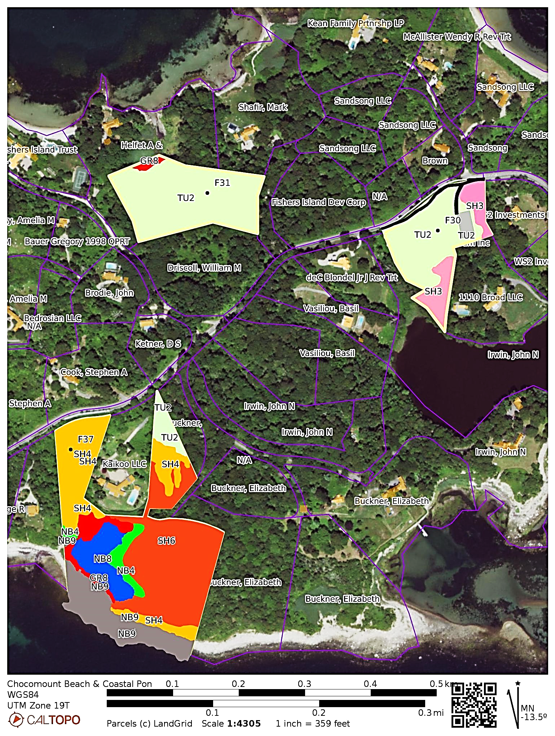

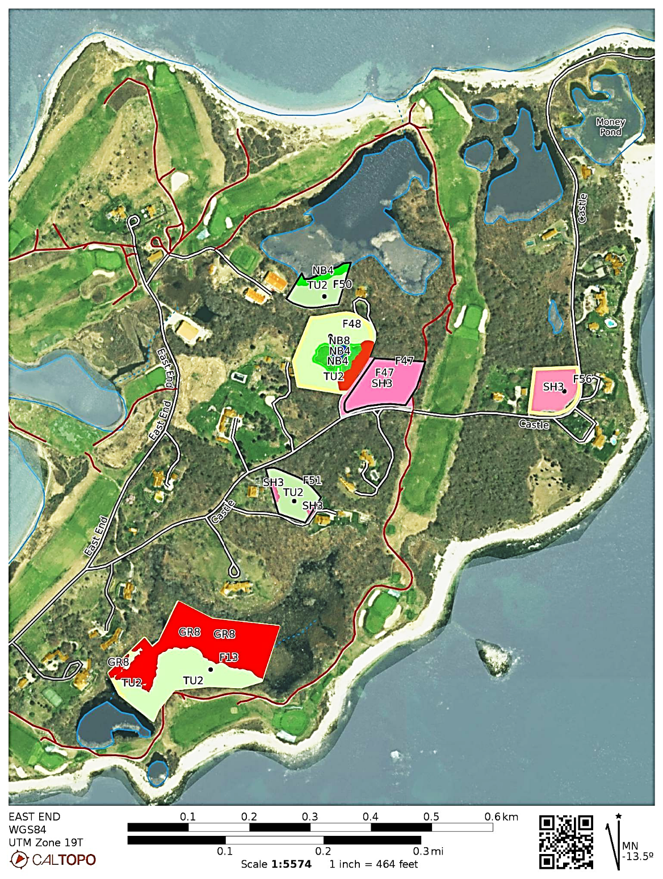
EAST END BY BIG CLUB AND MUD POND

The primary investigator of this project, Robert (Bob) Panko, is currently active in his 51st year of wildland fire management. He has been fully qualified by the NWCG as an Incident Commander Type 2, an Operations Section Chief Type 2, as a Strategic Operational Planner and as a Prescribed Burn Boss Type 2. These qualifications are the results of significant training and a lifetime of wildland fire experience that began with his long career with the US National Park Service. Bob has been a federally qualified prescribed burn boss since 1995 and has managed wildland fires nationwide. From 2019 to 2022 he established a prescribed fire program for the Central Pine Barrens Commission in Long Island. He has authored prescribed burn plans that cover over 8000 acres in Long Island. Much of that work involved identifying the fuel models and wildland fire risks to the adjacent wildland / urban intermix.
Appendix B of Fishers Island Biodiversity: Rare Species and Natural Communities of the Henry L. Ferguson Museum Land Trust, Gregory J. Edinger New York Natural Heritage Program
Standard Fire Behavior Fuel Models: A Comprehensive Set for Use with Rothermel’s Surface Fire Spread Model; 2005; Joe H. Scott and Robert E. Burgan; USDA Forest Service Gen. Tech. Rep. RMRS-GTR-153. 2005.
Interviews conducted with a variety of experienced Northeastern US wildland fire managers indicated that Maritime Shrub/Scrub patches were reluctant to burn unless driven by strong alignment with winds / fuels / slope and dry conditions. Ken Edwards, lifelong resident and former Fire Chief of the Fishers Island Fire Department, said he had never witnessed this Maritime Shrub/Scrub habitat burn. The US Forest Service Fire Effects Information System listed this habitat as a “stand replacement” ecotone with a fire return interval of 200 plus years (meaning It was expected to burn severely only once in a 200 year cycle).
It is noteworthy to comment here on these ratings. The risks ratings were established for this project to follow the general pattern of fire risks seen on Smokey Bear signs; something most people can relate to. The Low and Moderate represent very modest wildfires creating few if any threats. That is the majority of the wildfire risk rating for the FMLT parcels. The High rating indicates a higher level of fire behavior expected with the fuels present on the few parcels so rated. That fire behavior would only cause risk to structures / private woodlands directly against the parcel. Very High and Extreme ratings would indicate severe fire behavior would be expected. There were no Very High and Extreme ratings found on FMLT parcels. found for any of the FMLT parcels in this study.

