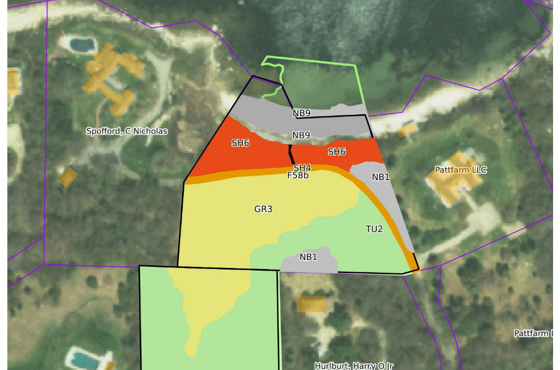
F58A and F58B Chocomount Trail

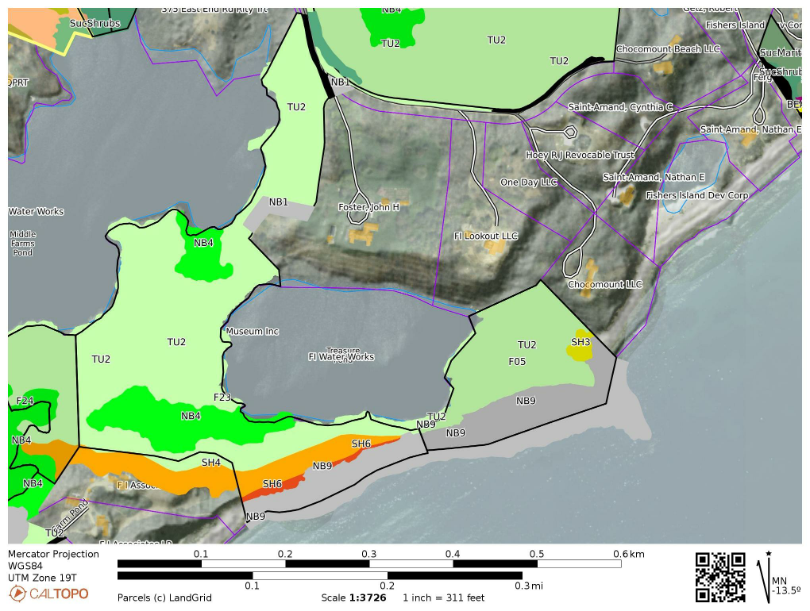

F23 Pitch Pine Rehab
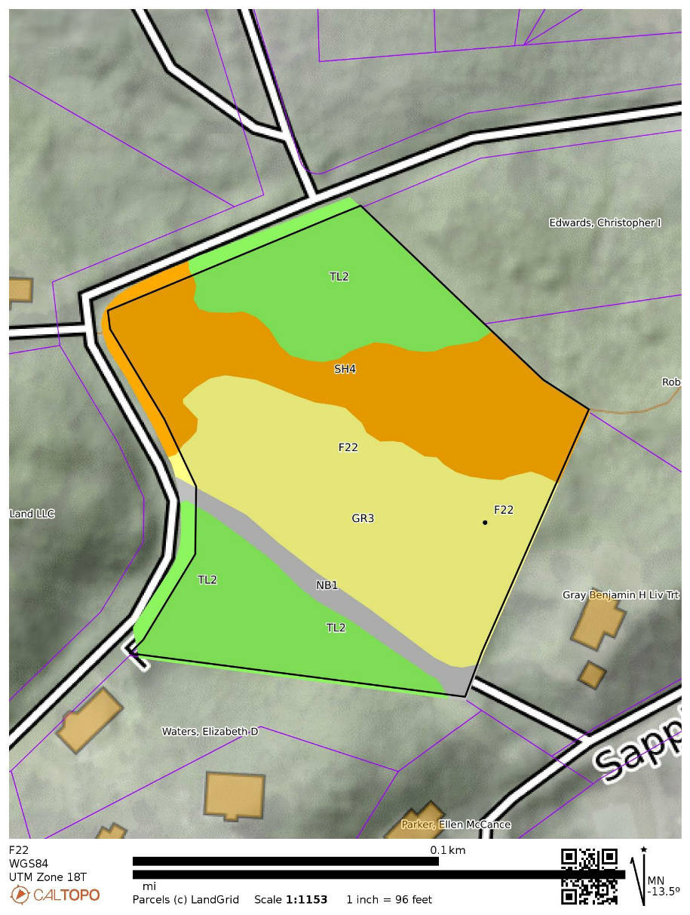

F22 Grassland Restore

F33 Skeet Range Grassland
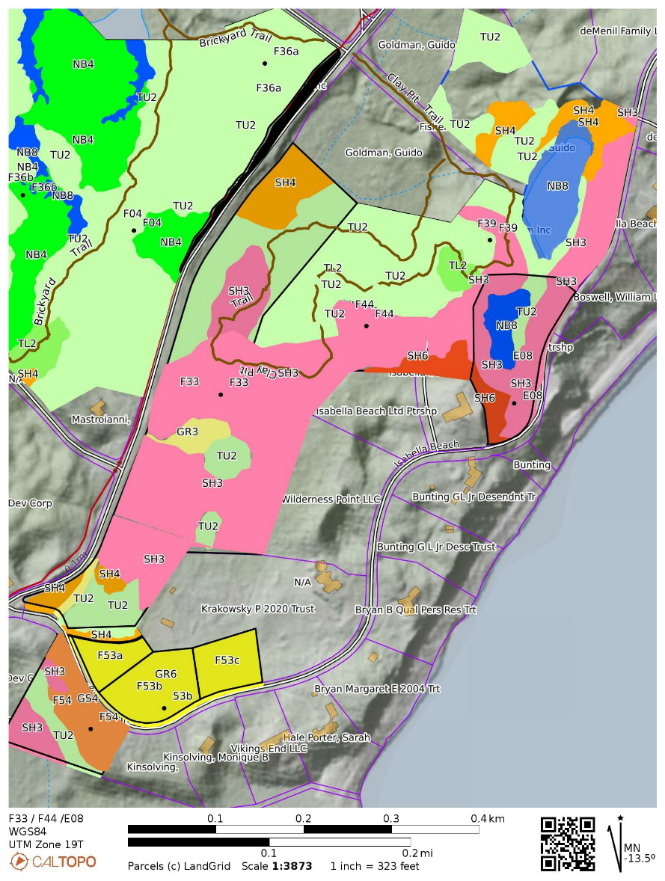

F53A / F53B / F53C /F54 Grasslands
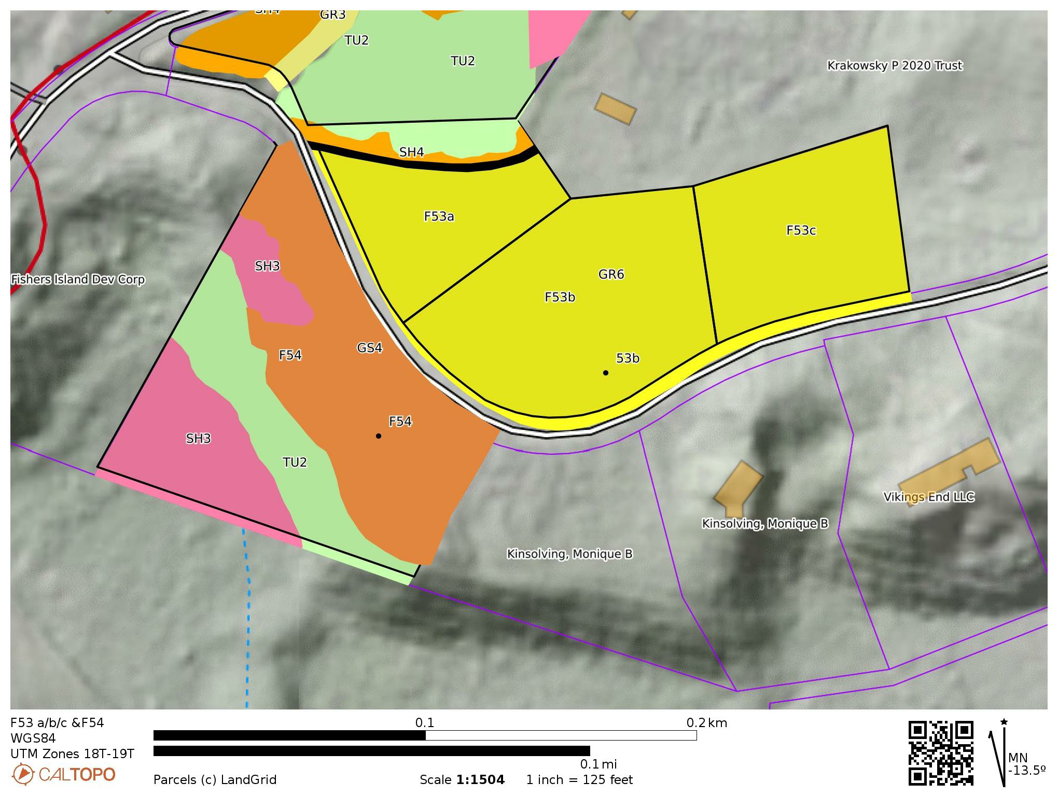

E05 Grassland
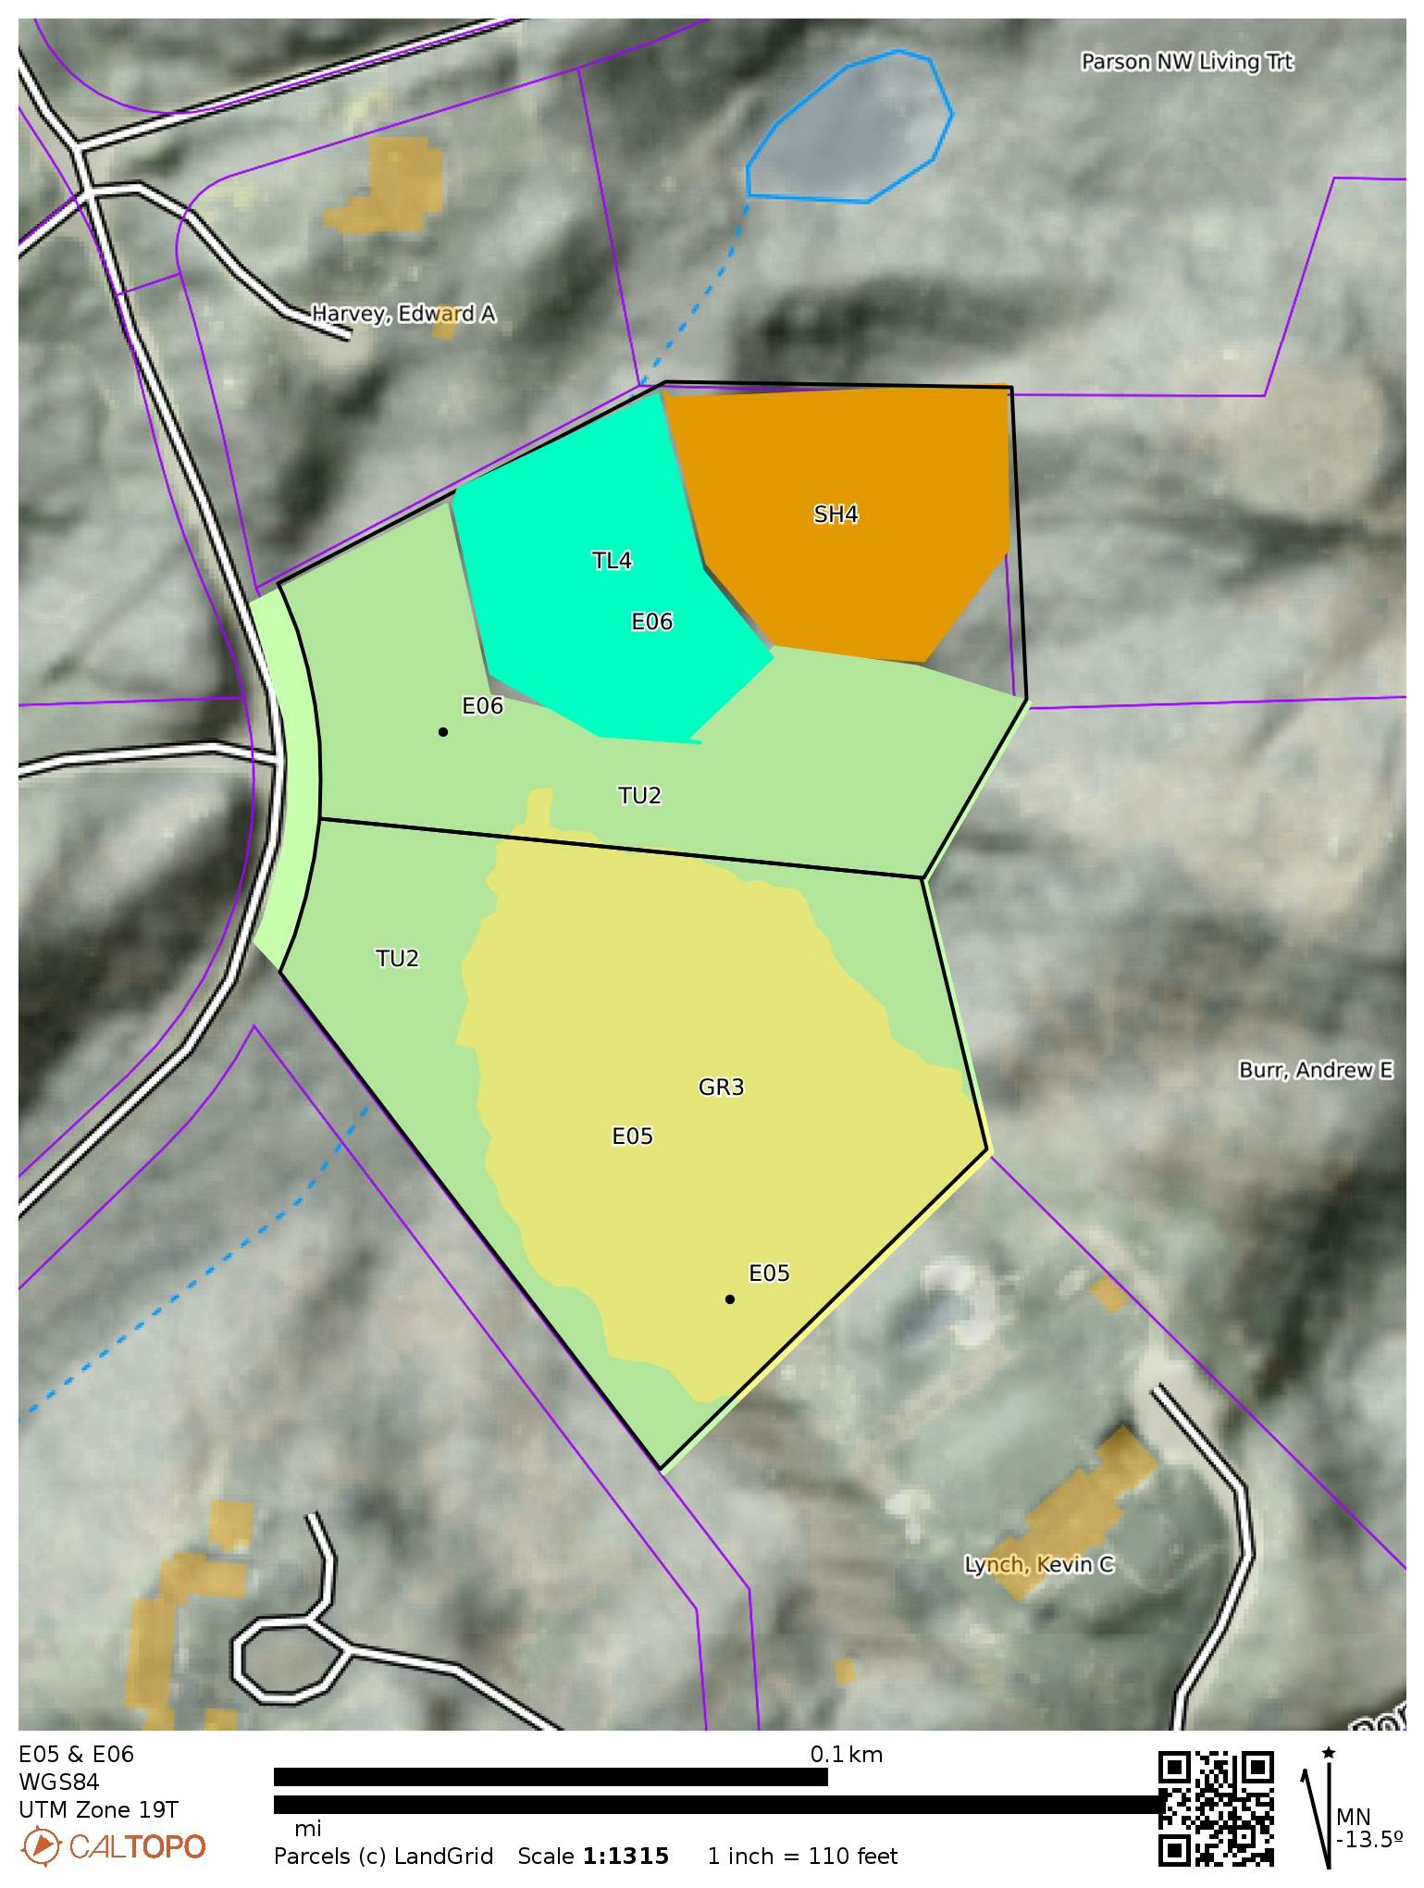

(F11) 1000-8.-1-4.14, (F35b) 1000-8.-1-4.26, (F20) 1000-8.-1-4.24, (E01) 1000-8.-1-4.15, (E-
03) 1000-8.-1-6.10 Middle Farm Flats

