Prescribed Burn Plan
Henry L. Ferguson Museum Land Trust
Middle Farms Flats Grassland Burn Unit
Fishers Island, Town of Southold
Suffolk County, New York

ffdsjk

Valid from September 01, 2022 until September 30, 2027


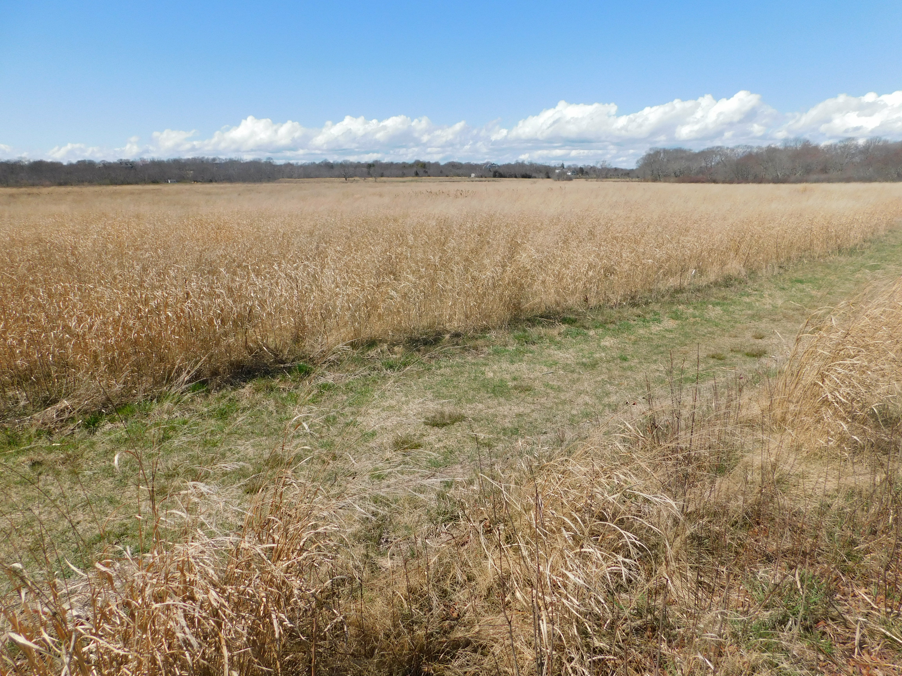
Prepared by: Bob Panko
Risky business Incident management llc. 259 Brown Road, Voluntown CT 06384
August 20, 2022
Table of Contents
Executive Summary: 2
1-Prescribed burn unit description: 3
2-Landowner or prescribed burn manager qualifications: 8
3-Goals and objectives: 8
4-Cover and fuel loads: 8
5-Timing and weather conditions: 10
6-Intensity and duration of burn: 12
7-Logistics: 13
8-Suppression: 17
9-Notification: 18
10-Communications: 18
11-Smoke management: 18
12-Required signatures and approvals: 19
References: 20
Appendices: 20

Executive Summary:

This is a prescribed burn plan for lands owned or managed by the Henry L. Ferguson Museum Land Trust. The area is on Fishers Island in the town of Southold, a part of Suffolk County NY. This burn plan is written under the provisions of New York State Regulations, Title 6, Lands and Forests, Part 194 Forestry Practices.

The burn unit is called the Middle Farms Flats Grasslands Burn Unit and it is made up entirely of grasslands.

These grasslands are important remnants of habitats that have significantly vanished in the current day Long Island and the northeastern United States in general. With 37 contiguous acres of native grass prairies in an isolated island setting, these grasslands are particularly important to restore and maintain. In addition to being host of various native plant and animal species, and aesthetically pleasing for public recreational use, these grasslands also serve as a nesting, resting and feeding ground for waterfowl and migratory birds. Although preserved from future development, these grasslands are continually threatened by invading native and non-native species which threaten to change the character and plant composition of these grass prairies. Prescribed fire is a means of restoring and maintaining native plant habitats.

Resource management alternatives for these grasslands were reviewed by Suffolk County scientists in 2011 and 2012. They recommended a combination of prescribed burning, mowing and other non-native species control actions to maintain the unique ecological characteristics of this maritime grassland. (Weigand, Coastal Maritime and Cool Season Grassland Management Recommendations for Henry L. Ferguson Museum and Land Trust Matty Matthiessen Wildlife Sanctuary & Grassland, 2012)
The resource management objectives of these grasslands are to restore and maintain the abundance of native grasses and forbs, to prevent and reduce the presence of non-native plants and to limit the encroachment and establishment of woody plants (including native woody plants) in the grasslands. From the social perspective, management objectives include preventing uncontrolled wildfires in these grasslands by reducing the amount of fuels available for wildfires. Should wildfires occur, there is after all no rapid mutual aid assistance available for the Fishers Island Fire Department due to remote island access. Fuel reduction is accomplished by mowing and conducting prescribed burns in a rotation that helps maintain fire breaks. This prescribed burn plant supports achieving these objectives.

Since as early as 2010 this grassland area has been managed with a combination of controlled burns and mowing. In the past a burn plan to authorize this burning activity was applied for annually by the Ferguson Museum Land Trust. In an effort to reduce the volume of handling and review involved in this planning and approval process and to expand burning window seasonal flexibility we are submitting this plan to cover a five year span. This will expand the opportunities to burn under optimal burning conditions and also support special projects to control non-native invasive species if needed. A multi-year plan allows the land managers and Fishers Island Fire Department to work without the time sensitive pressure of having to complete the burn during a one year period, allowing for more days to choose optimal weather conditions. The multi-year plan also reduces duplication of work on behalf of both the landowner and the State of New York, reducing costs to both entities.

New York State Regulations, Title 6, Lands and Forests, Part 194.1 defines that requirements for prescribed burn plans on non-DEC lands are covered in Part 194.5. Part 194.5 describes 12 elements that must be included in a plan for private lands. This plan will address all twelve of these elements and will also include additional information above and beyond these requirements that additional information. This plan uses the 12 sections that are required to be included in a prescribed burn plan for non-DEC Departmental lands as its outline. For reference, the information that is required to be covered from Part 194 is directly quoted in the plan.
The entire grassland has been divided into 3 sections. Generally one section is to be burned each year. Individual sections have been burned successfully since 2016 and the plan is to continue with this rotational burn schedule. This plan however is written for a five year period and does not dictate exactly when specific portions are burned. The plan instead allows land managers and prescribed burn managers to make decisions about desired burn rotation and scheduling based upon actual burn accomplishments and identified future needs. That allows for fully adaptive management of the grasslands and taking advantage of lessons learned from one season to the next.

1-Prescribed burn unit description:

“A map at the appropriate scale and a narrative description identifying the area or areas on which prescribed burn activities will be undertaken.” (Part 194.5)

The Middle Farms Flats Grassland Burn Unit is in the Town of Southold on Fishers Island, Suffolk County, New York.
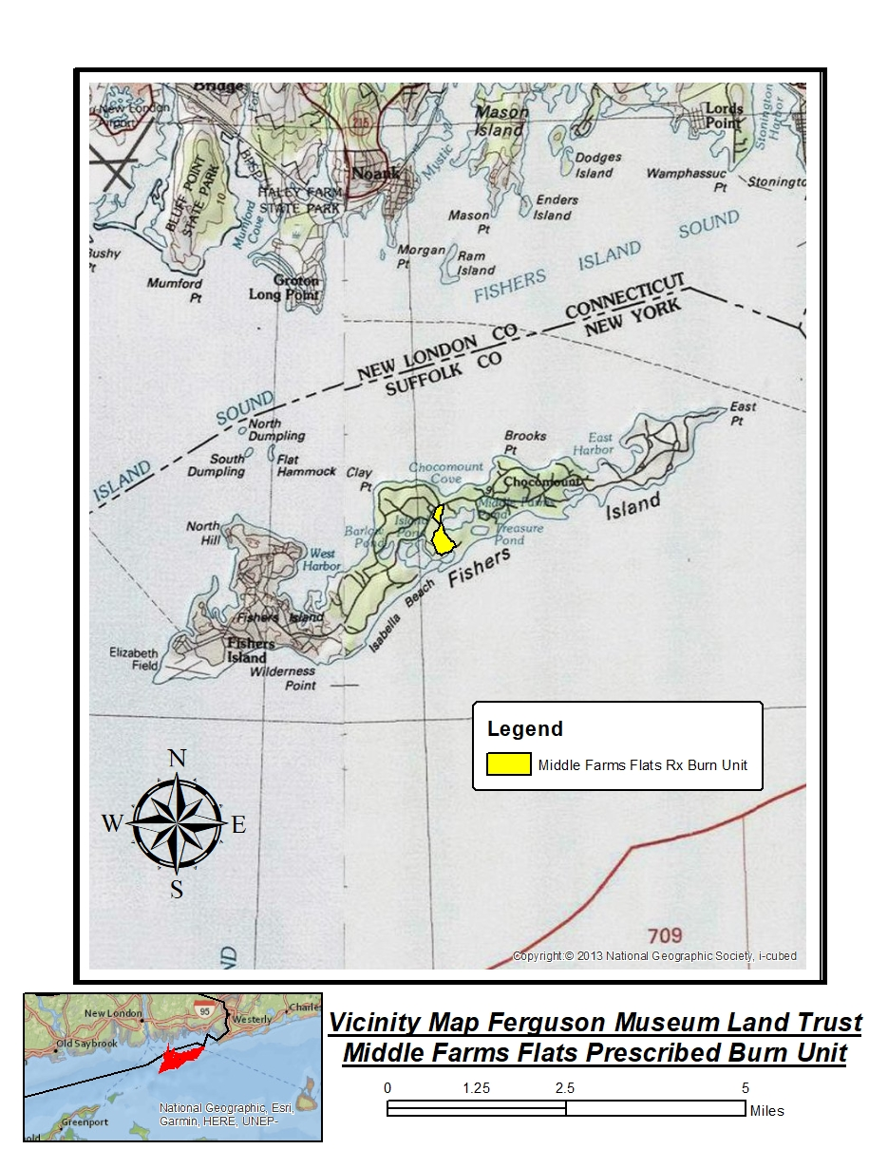
Fishers Island is located at the eastern end of Long Island Sound between Fishers Island Sound and Block Island Sound. The generally east-west running island is 3-5 miles south of the southern shoreline of New London County, Connecticut.
Fishers Island is accessible by boat or airplane. The only commercial ferry services come from nearby New London and Noank, Connecticut. There are two marinas on Fishers Island for private vessel mooring. Elizabeth Field Airport on the western tip of Fishers Island is a public use airport. It is owned by the Town of Southold and managed by the Fishers Island Ferry District. There are commercial airlines that fly there from numerous states and it is open to private aviation.
The burn unit is on the Middle Farms Flats portion of Fishers Island. This area is located virtually in the center of Fishers Island.
A central geographic reference point for the burn unit is Latitude: N 41 16' 16.33" Longitude: W 71 58' 49.11".
The grassland burn unit totals 37 acres and all of these acres are available for prescribed burning.

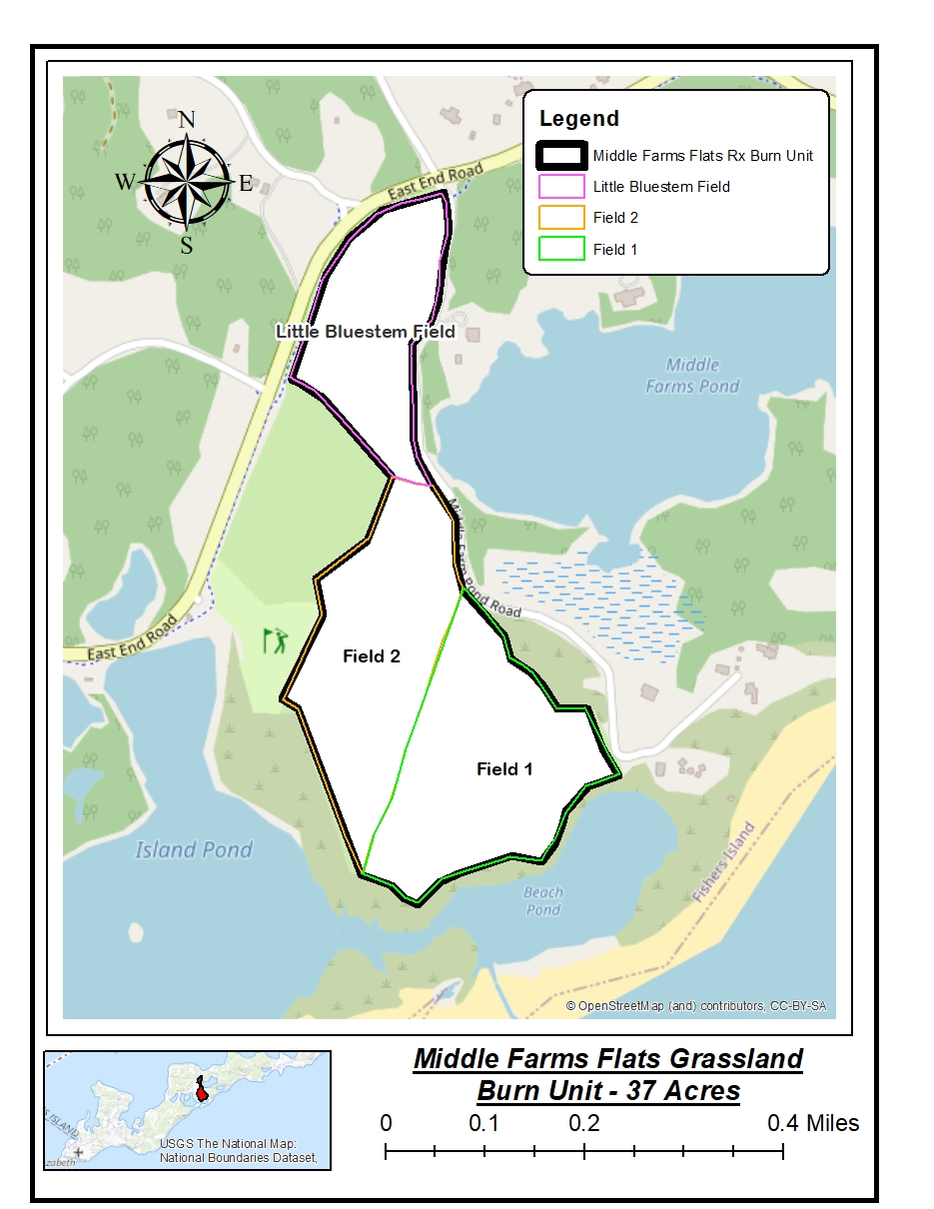
These grassland fields are immediately east of East End Road and south and west of Middle Farm Pond Road. The burn unit abuts the Fishers Island Club’s golf driving range to the west. Island Pond abuts the burn unit property to the southwest, and Beach Pond is adjacent to the south. A small tidal creek connects these ponds along the southern border of the burn unit. Both of these ponds are brackish ponds connected to Block Island Sound by a narrow breachway that crosses the barrier beach against the Sound.
The Henry L. Ferguson Museum Land Trust owns the majority of the burn unit, however 3.4 acres in the southeast corner of the grassland is a conservation easement granted by the Robert Miller family to the Ferguson Museum Land Trust.

Burn Blocks within the Burn Unit:
Little Bluestem Field Burn Block, 9.4 acres
Description: The Little Bluestem field is the northern most of the three burn blocks. It is bounded by East End Road to the west, Middle Farm Pond Road to the east and the closely mowed golf driving range to the south.
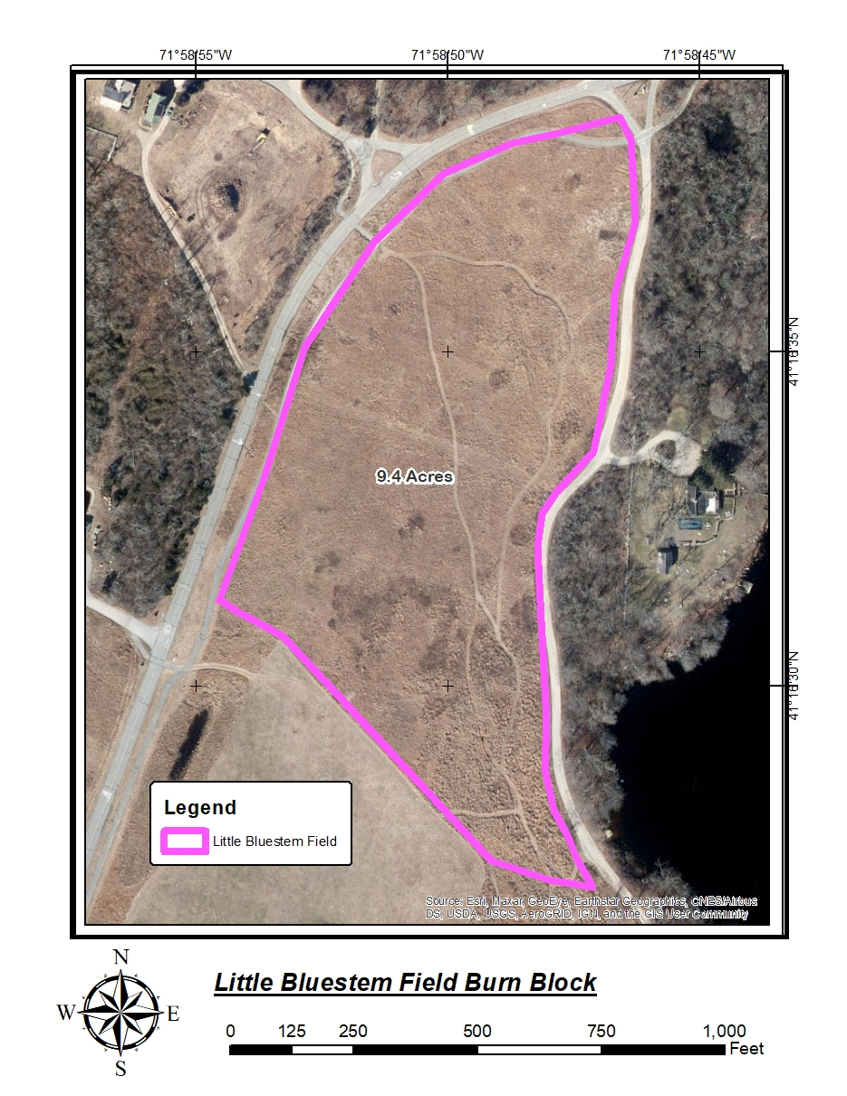
Ownership: The Little Bluestem field is owned entirely by the Ferguson Museum Land Trust. The adjacent golf range is owned by the Fishers Island Club. The adjacent roadways are owned by the Fishers Island Development Corporation (FIDCO) who manage the roadways and other common grounds of portions of Fishers Island. It should be noted that right of way ownership along East End Road extends from the roadway centerline to the paved parallel bicycle path to the east of the roadway.
Fuels: The fuel models described in this plan are all from the published “Standard Fire Behavior Fuel Models: A Comprehensive
Set for Use with Rothermel’s
Surface Fire Spread Model”, US Forest Service General Technical
Report RMRS-GTR-153. June 2005 authored by Joe H. Scott and
Robert E. Burgan

Little Bluestem field fuels consist of GR3, Low Load, Very Coarse Humid Climate Grass (Dynamic) as published in this guide. These fuels are native grasses, about 2 feet tall, with good horizontal continuity. The fuel loading is about 2 to 3 tons per acre. The word “Dynamic” in this fuel models name means that this is a fuel that changes in character throughout the year. In winter and spring these grasses are dry, dormant stems with low moisture content. Eventually as summer approaches new growth appears from these annual grasses. The new growth is fresh and green and has a high moisture content. Eventually by mid-May to early June these grasses fully mature and have a high enough moisture content that they will not burn. Also present in this fuel bed are patches of invading hardwoods including black locust, cherry and sumac.

Management Actions: This grass field may be mowed in years when the field is not scheduled for burning. Generally burning will be conducted in early spring to early summer (mid-March until early May) or in the fall once the grasses become dormant and cure (late September until November). The entire field may be burned at one time or the field can be broken into small burn patches by mowing firebreaks. When mowing patches prior to burning the lines should but cut along straight lines regardless of the curving nature of the mowed hiking trails that crisscross the field (widen the hiking trails and mow the edges of the curves).

Field 2 Burn Block, 13.2 acres
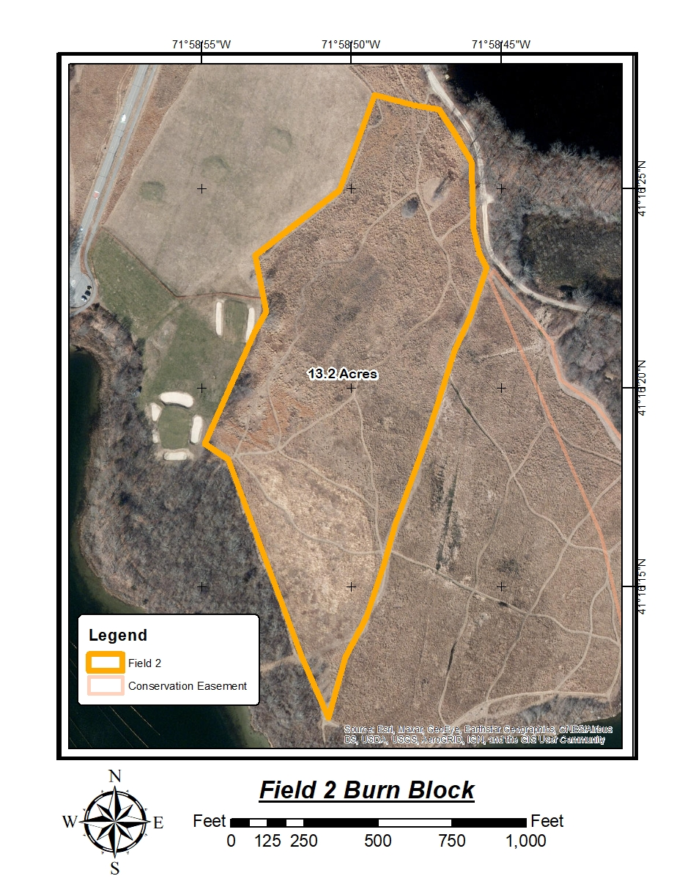
Description: The Field 2 grassland is the central of the three grassland burn blocks in the burn unit. It is bounded to the northwest by the golf driving range and practice area, to the southwest by timbered lands that abut Island Pond, to the east by the Field 1 burn block, to the northeast by Middle Farms Pond Road and timbered lands, and the to the north by the Little Bluestem Field burn block.
Ownership: The Field 2 grassland field is owned entirely by the Ferguson Museum Land Trust. The golf range is owned by the Fishers Island Club. The adjacent roadways are owned by the Fishers Island Development Corporation (FIDCO) who manage the roadways and other common grounds of portions of Fishers Island. All other lands immediately adjacent to the Field 2 burn block are owned or managed under easement by the Henry L. Ferguson Land Trust.
Fuels: The Field 2 fuels consist of GR3, Moderate Load, Humid Climate Grass (Dynamic) in the northern 2/3 of the burn block and GS3, Moderate Load, Humid Climate Grass-Shrub (Dynamic) in the southern third of the block, an area that is heavily invaded by staghorn and winged sumac and other invading hardwoods.
Management Actions: This grass field may be mowed in years when the field is not scheduled for burning. Generally burning will be conducted in early spring to early summer (mid-March until early May) or in the fall once the grasses become dormant and cure (late September until November). The entire field may be burned at one time or the field can be broken into small burn patches by mowing firebreaks. When mowing patches prior to burning the lines should but cut along straight lines regardless of the curving nature of the mowed hiking trails that crisscross the field (widen the hiking trails and mow the edges of the curves).

Field 1 Burn Block, 14.4 acres
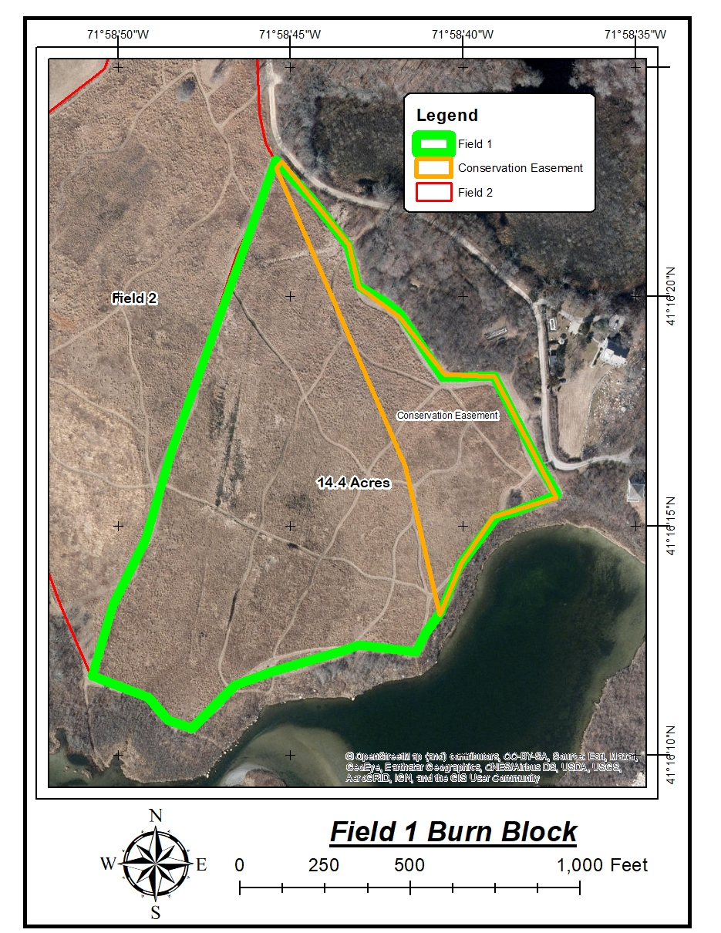
Description: The Field 1 grassland is the southern most of the three grassland burn blocks in the burn unit. It is bounded to the west by the Field 2 burn block, to the south by timbered lands that abut Island Pond and Beach Pond, to the east by timbered lands between the grassland and Middle Farms Pond Road.
Ownership: Most of the grassland is owned by the Land Trust. As indicated in the map the eastern 3 acres of the grassland is owned by the Robert Miller family whose home is on that property. These lands are under management by the Land Trust under conservation easement. The timbered lands adjacent to the grassland are owned by the Land Trust or under conservation easement from the Miller family.
Fuels: Field 1 fuels consist of GR6, Moderate Load, Humid Climate Grass (Dynamic).
These fuels are native grasses, about 3 feet tall, with good horizontal continuity, approximately 3-4 tons per acre.
Management Actions: This grass field may be mowed in spring in years when the field is not scheduled for burning. Generally burning will be conducted in early spring to early summer (mid-March until early May) or in the fall once the grasses become dormant and cure (late September until November). The entire field may be burned at one time or the field can be broken into small burn patches by mowing firebreaks. When mowing patches prior to burning the lines should but cut along straight lines regardless of the curving nature of the mowed hiking trails that crisscross the field (widen the hiking trails and mow the edges of the curves).

2-Landowner or prescribed burn manager qualifications:

“A description of the landowner's or prescribed burn manager's training and expertise in conducting prescribed burn activities.” (Part 194.5)

The prescribed burns will be conducted by the Fishers Island Fire Department in conjunction with the Ferguson Museum Trustees and/or staff. The Chief of the Fishers Island Fire Department, or their designee, would be the burn manager. Presently Jeff Edwards is the Chief of the Department. Edwards has been the burn manager of multiple prescribed burns conducted on Fishers Island. Fishers Island Fire Department member and Henry L. Ferguson Museum Trustee Steve Malinowski has also served as the Burn Manager in the past and may assist as a deputy burn manager. The burn manager will have the entire resources of the Fishers Island Fire Department available for burning including fire and support apparatus as listed in the Logistics section of this plan. Henry L. Ferguson Museum Land Trust personnel and apparatus are also available for support on burn day and are the resources that do pre-burning site preparation and mowing.

3-Goals and objectives:

“A description of the ecological purposes and objectives of the prescribed burn, including an identification of the specific species or natural communities that are intended to be affected by the burn.” (Part 194.5)

Bum unit management goals:
1- To discourage overgrowth and enhance the growing conditions for the diverse natural assemblage of warm season grassland species.
2- To eliminate fuel for fires that may be accidentally ignited under unfavorable circumstances. Fishers Island Fire Dept. has no availability of mutual aid and it is crucial to prevent brush fires when the wind is in a dangerous direction.
3-To reduce the tick populations by direct mortality during burns, thereby reducing transmission of tick borne diseases to humans and wildlife.
Specific bum objectives
4-Top-kill non-herbaceous vegetation as determined by observations immediately post burn.
5-Keep the fire within the burn unit thereby protecting adjacent public and private property and infrastructure as well as adjacent wetlands. There are no sensitive natural or cultural resource within the burn unit.

4-Cover and fuel loads:

“A description of the vegetative cover and fuel loads on each area to be subjected to prescribed burning.” (Part 194.5)

Cover and fuel loads:
The vegetation to be burned is primarily tall grass with emergent woody shrubs. The fuel models described in this plan are all from the published “Standard Fire Behavior Fuel Models: A Comprehensive Set for Use with Rothermel’s Surface Fire Spread Model”, US Forest Service General Technical Report RMRS-GTR-153. June 2005 authored by Joe H. Scott and Robert E. Burgan

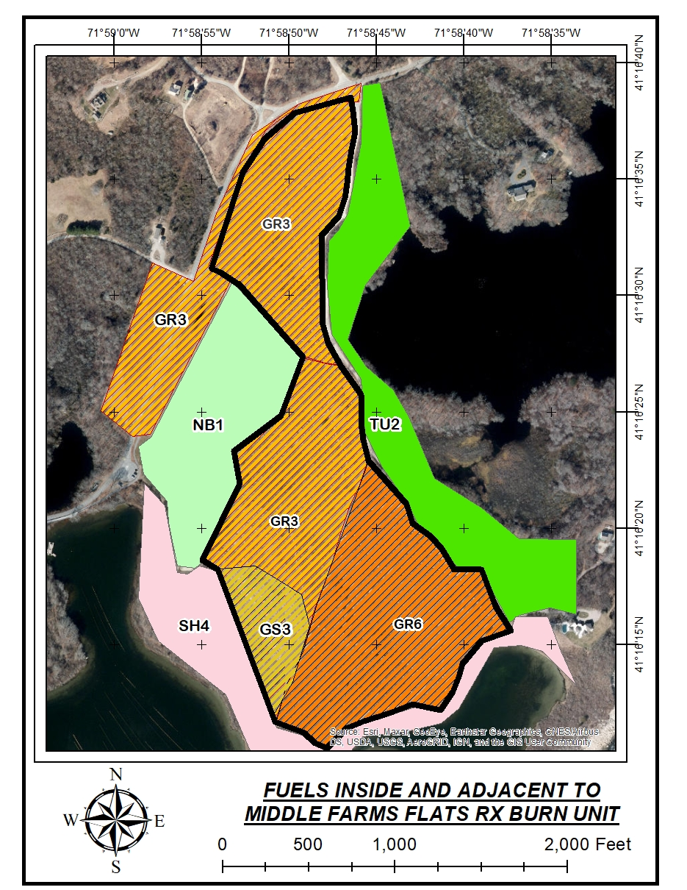
Fuel models are determined by the primary fuel that will carry fire in an area. The primary carrier of fire in these grasslands is the emergent native grasses. The grasslands consist of GR6, Moderate Load, Humid Climate Grass (Dynamic), GR3 Low Load. Very Coarse, Humid Climate Grass (Dynamic) or GS3, Moderate Load, Humid Climate Grass-Shrub (Dynamic) as published in the Scott and Burgan guide. These fuels are native grasses, about 1-3 feet tall, with well-established horizontal continuity. The fuel loading in this burn unit varies between 1 to 4 tons per acre. The word “Dynamic” in this fuel models name means that this is a fuel that changes in character throughout the year. In winter and spring these grasses are dry, dormant stems with low moisture content. Eventually as summer approaches new growth appears from these annual grasses. The new growth is fresh and green and has a high moisture content. Eventually by mid-May to early June these grasses fully mature and have a high enough moisture content that they will not burn.

These grasslands are being invaded by woody species, both native and non-native, but presence of these species is relatively anecdotal with respect to fire behavior. The invasive woody plants include staghorn sumac, winged sumac, black locust, cherry, maple and bay.

The grasslands are also invaded by numerous other herbaceous plants, both native and non-native. These plants do not contribute to the fuel loading. Depending upon the season of the burn and the intensity of the burn these plants are unlikely to be impacted by the burns directly, as some perennials’ or annual plant might not yet have emerged from the ground prior to burning. One advantage to burning however is that undesirable plants may emerge immediately after burning and, with the dormant grasses burned off, be readily visible and accessible for direct removal, chemical or other control treatments.

Immediately adjacent to the burn unit are GR3 grasses in the North Field and adjacent to East End Road, NB1 Non-Burnable developed land on the golf range, SH4 Low Load, Humid Climate Timber-Shrub in the wooded areas immediately west and south of the burn unit, and TU2 Moderate Load, Humid Climate Timber-Shrub in the forested areas east of Middle Farms Pond Road.

5-Timing and weather conditions:

“A description of physical conditions, such as time of year, wind speed and direction, and air temperature and humidity, which must be met before a prescribed burn is initiated.” (Part 194.5)
Seasons for burning: This plan is written for year round use and burning may occur at any time of the year as determined by management. The grasslands will “green up” in summer and the fine fuels become “live fuels” with fuel moistures at or above 150%. With those live fuel moistures these grasslands will not burn.
In order to control undesirable invasive plant species management may opt to mechanically or chemically treat portions of the grasslands. Subsequent to such treatments enough fine dead fuels may be available to burn, and prescribed burning of those patches may be a desirable follow-up to the treatments even in the summer months.
General weather conditions on site: The prevailing winds on Fishers Island are southwest and west. These winds are documented using archived weather data from the private weather stations (Wunderground.com Fishers Island - KNYFISHE14 at 18073 E Main Rd (East End Road), Fishers Island and KNYFISHE13 located at Edwards Lobsters, Madeline Ave. on Fishers Island).
The orientation of the landing strips at Elizabeth Field Airport also supports this prevailing wind determination with runways (7-25; 12-30). Airport landing strips are generally designed to allow planes to fly headfirst into the wind during landing and takeoff when possible, and the two strips at Elizabeth Field are oriented on vectors of 250 degrees (SSW) and 300 degrees (WNW), ergo aligned along prevailing winds.
Analysis of the historical weather conditions was conducted using weather data from the private weather stations listed above, and using data from the nearby Groton Airport weather station. The prevailing winds in spring summer and early fall are SW. Fall through March the prevailing wind is W. SW is the dominant vector. In spring and summer that dominant direction is modified by wind swings to S and W. In the cooler months frontal systems come through with shifts to W, NW and N modifying the average to W. These weather/wind patterns mimic the overall conditions throughout Suffolk County NY.
Fire Prescription:
The following are useful websites to access weather parameters in advance of planning to burn on a given day to make certain that the weather parameters are predicted to fall within the requirement of the prescribed burns “prescription”.
Natl Weather Service Fire Weather Forecast:
https://forecast.weather.gov/product.php?site=NWS&issuedby=OKX&product=FWF
This forecast is issued daily from the NWS office in Upton, NY at the Brookhaven National Lab. The detailed information for Fishers Island would best be viewed in the portion of this daily forecast labeled “Southern New London” county. Use of the Southern New London county forecast as the is best for Fishers Island was verified with Tim Morrin, Fire Weather Program Leader, NWS, Upton, NY. This forecast will provide:
- the predicted 20’ wind speed and direction
- the predicted mixing height
- a discussion of the weather outlook overall
Estimating Fine Dead Fuel Moisture (the moisture of 1 hr. fuels): Appendix B contains the tables that are available at the link below for estimating 1 hour fine dead fuel moisture. They are also available at the following website.
https://kestrelinstruments.com/mwdownloads/download/link/id/251
On Site Weather Stations Fishers Island:
KNYFISHE14 at 18073 E Main Rd (East End Road), Fishers Island
https://www.wunderground.com/dashboard/pws/KNYFISHE14
KNYFISHE13 at Edwards Lobsters, Madeline Ave, Fishers Island
https://www.wunderground.com/dashboard/pws/KNYFISHE13
Spot Weather Forecasts:
The afternoon before a planned prescribed burn the Burn Manager or designee can request a custom “Spot Weather Forecast” from the US National Weather Service. This SPOT would be prepared by the forecasters in the Upton, NY office. The SPOT is a custom forecast for your precise latitude and longitude. For assistance in obtaining a spot contact Tim Morrin, Fire Weather Program Leader, tim.morrin@noaa.gov , 631-357-2055. This forecast is available free and is generated using the link below:
https://www.weather.gov/spot/
General Instructions for Obtaining a SPOT Forecast:
Usually a SPOT for a Prescribed Burn is request late afternoon the day before burning.
Open the NWS Spot Link above and click on Submit Spot Forecast button
Step 1 – Zoom in on the map and click on the Middle Farms Flats to set the SPOT location
Step 2- Click on Prescribed Fire as the type of request
Step 3- Click on the Generate a Spot Request button
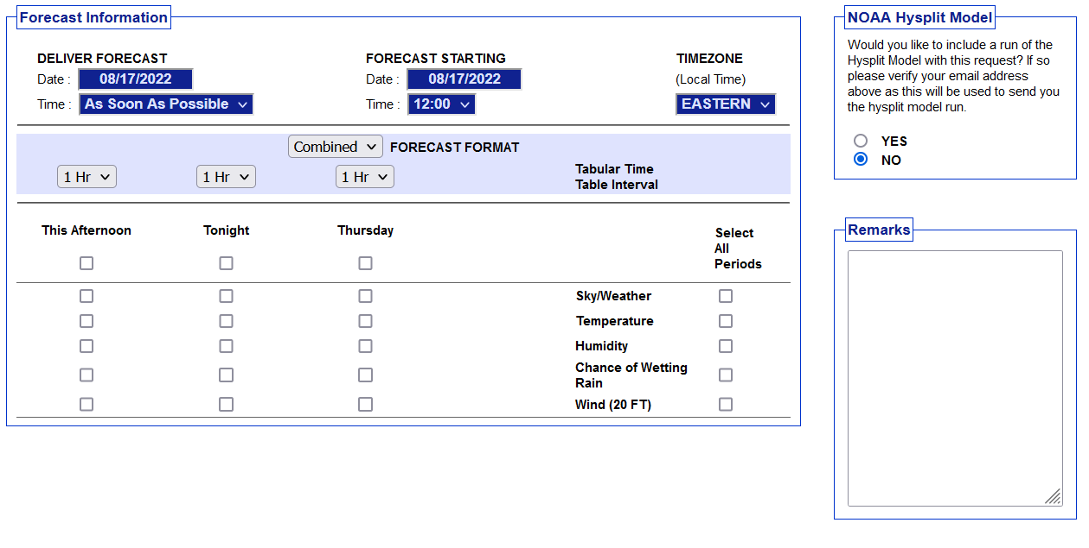
Step 4- Complete the request by filling in the information requested. Generally you can ask for the Deliver Forecast Time to be set at about 0500 hours the next day and you can set the Forecast Starting about 0700 the day of the burn. You can then select what periods you want covered and what data to be in the forecast (choose all the types listed Sky/Weather, Temp, Humidity, Chance of Wetting Rain, 20ft Winds. You can add remarks stating when you intent to burn. Once a preliminary forecast is created it will be emailed to the address entered into the form.
You can also access your completed SPOT by opening the Spot forecast link above and clicking on the Monitor Spot Forecasts button.
The following table contains the physical conditions that must be present at the time of ignition on a burn day.
Fire Prescription
FACTOR | Minimum | Maximum | Comments
Temperature (F) | 30 | 95 | Obtain from local forecast, fire weather forecast, or observation.
Relative Humidity (%) | 25 | 75 | Obtain from local forecast, fire weather forecast, or observation.
Wind Speed, 20’forecasted (MPH) | 1 | 20 | 20’ wind is part of daily fire weather forecast and therefore easily viewed in a forecast allowing burn manager to evaluate GO/NO-GO for a burn day in advance. The eye level forecast winds can be computed by multiply the predicted 20’ wind speed X 0.4 (e.g. 20’ @ 10 mph X 0.4 = predicted eye level winds at 4 mph) to determine if winds are predicted within prescription Min/Max
Wind Speed, eye level (MPH) | 1 | 10 | Measured on site with handheld wind gauge to ensure prescription is met
Wind Direction | S, SW, W, NW, N, NE |  | No winds out of the East to Southeast. Obtain from local forecast, fire weather forecast, or observation.
1 Hour Fuel Moisture % | 5 | 13 | Compute using the tables in Appendix B to determine if fuels are within prescription or at this link:  https://kestrelinstruments.com/mwdownloads/download/link/id/251
10 Hour Fuel Moisture % | 6 | 20 | Generally about 3-5% higher than 1 hr. fuels
Mixing Height (Feet) | 1500’ | No Max. | This is the height smoke will rise to in the atmosphere. 1500 feet is minimum forecasted value to meet prescription minimum. The higher this number is the better as smoke will lift and disperse more readily. The mixing height is part of the Fire Weather Forecast and is also in the SPOT when requested.
Days Since Rain | 2 | 5 | Recommended guideline as indicator of dead fuel moisture levels. This is only a recommendation, not prescribed requirement.
Season | Year-Round |  | Generally March-April-early May are the spring burning season and September-October are the fall season. There is no restriction on burning at other times of the year however.

6-Intensity and duration of burn:

“A description of the anticipated intensity and duration of the prescribed burn, such as flame length and rate of spread, given the fuel loads and physical prescriptions described.” (Part 194.5)

Fire behavior prediction modeling for these fuels was conducted using the Behave Plus 6.0.0 free software developed and distributed by the US Forest Service, the federal interagency Joint Fire Science Program and Systems for Environmental Management. The fuel modeling data outputs can be viewed in Appendix A of this Plan.
Empirically this Behave data mimics what experience in these grassland fuels would lead the burn manager to conclude so the outputs are aligned with actual experience and seem reliable.
Simply put, under the driest and windiest conditions these grassland fuels have very fast rates of fire spread, will produce head fire with very long flame lengths and run very closely in the direction of the winds on this flat terrain. These are wind and fuel driven fires. Saying that early in the spring season, at the dry end of the prescription with 1 hr “fine fuel moistures” at 5-7%, winds are preferred at the low end of the scale, 1-5 mph at eye level. When fine fuels are in the wetter end of the prescription (9-13%) or when grasses begin to “green up” in late April and early May higher wind levels may be desirable, 6-10 mph eye level.
The prescription also allows for burning conditions anticipated in the fall. Fall daylight hours are much less than spring and generally there is a longer period of full recovery of humidity hours overnight in the fall. This makes for cooler burning conditions which may require winds at the higher end of the prescription to accomplish the resource objectives.
This plan and prescription also identifies the possibility of burning of mechanically or chemically treated patches of grass in months when fire would not normally carry in these grasslands. In mid-summer a mechanically or chemically treated acre patch, once cured, can easily be burned without concern of escape when surrounded by untreated full vigor grasses, forbs or other herbaceous plants that are at 150% or more live fuel moisture.
The wind vectors allowed in the prescription (winds coming from the S-SW-W-NW-N-NE) will drive the smoke away from occupied areas and for the most part adjacent roads.
Paved surfaces and gravel roads along the burn perimeter will anchor the fire and will be augmented by mowed fire breaks. Ignition patterns will be discussion at greater length in the Logistics element of this plan.
Each active burn will usually last no more than one hour. Once the main fire has passed, residual interior burning will be minimal and limited to dead and dry sticks from the invading hardwoods. Those will be allowed to burn themselves out if possible, or they will individually be mopped up before sunset on the burn day.
The prescription recommends that at least 2 days of drying be allowed before burning if a wetting rain of 0.1” or more is received on the burn unit.
The probability of ignition (PIG) from a flaming fire brand is directly related to the fine fuel moisture condition and the air temperature and the predicted tables are found in Appendix A. Succinctly the probabilities of ignitions are in the 50’s and upper 60’s % with extremely dry fuels at the low end of the prescription and in the 20’s and 30’s at the wetter end of the prescription. The PIG can also be calculated using tables in Appendix B.
These values will all be reflected in the ignition sequence described in the Logistics element that follows.

7-Logistics:

“A description of the logistics of the prescribed burn operation, number of personnel and description of duties, and fire management equipment that will be deployed to assure that the burn is restricted to the area or areas identified for prescribed burn management. This will include but not be limited to a description of the method of ignition, ignition pattern, containment, mop-up and patrol procedures.” (Part 194.5)

Preburn preparations:
Before burning fuel breaks will be mowed between the burn units. Fuel breaks should be 20’ wide in total, and should be aligned as straight as possible, in places overlapping the edges of curved walking paths normally mowed in the fields. Where possible the breaks should run NE-SW to match prevailing wind alignment. If possible the fuel breaks should be raked with a tractor after mowing to remove chaff, but this is not a requirement.
Equipment Assigned on Burn Day:
At least two Fishers Island Fire Department trucks will be assigned. Rescue 3 is a Brush Truck with 250 gal. tank and is the most tactical engine and has 2 booster hose reels. Engines 1 and 2 are Class A Pumpers (ENG1) and each carry 1000 gal. of water. These engines all have full complement of hose and tools.
Personnel and Duties:
A Burn Manager will be assigned who is the incident commander and directs the entire burn operation. At minimum a single additional firefighter should be assigned directly to the Burn Manager to serve as the ignition person. A minimum of 3 personnel will be assigned to each of the fire trucks. Personnel will use booster hoses and hand tools to hold the edges of the burnout. The wet line technique may be used to pre-wet the mowed edges immediately prior to ignitions. Wet lining is spraying water on the mowed stubble of the fire break to minimize the chance that it could catch fire outside of the planned burn. Wet lining can also be used on other adjacent fuels that are outside the burn area. Be mindful that “wet lines” evaporate quickly and are best applied in concert with adjacent ignitions and they require large amounts of water.
How Fire Behaves on the Ground:
Knowing how fire behaves in a flat grassland is critical to understanding how we plan to start ignition of a prescribed burn and how we conduct the ignitions as we continue to ignite the block. When fire is placed on a flat grassland it is highly influenced by the wind. If there is no wind and a spot of fire is placed on the ground the fire will burn a circle. It is rare however to have no wind, and in fact our prescription requires at least a 1 mph wind to conduct the burn.
So when a spot of fire is placed on the ground wind is going to push the fire in the direction the wind is blowing. The fire that runs in the direction the wind is pushing it is the head fire and it can be considered as the fire “running with the wind”. Head fire is the hottest, has the longest flame lengths and is usually the most concerning part of a wildfire. Fire at windward edge of the spot of fire we put on the ground (opposite of the head fire) will “back” its way into the wind. These backing fires have the shortest flame lengths and move slowly back toward the wind source. Although less intense than the head fires, by moving slowly, backing fires have longer duration of heat on the vegetation and duff than a running head fire. Backing fires sometimes are more effective at top killing invasive shrubs or consuming organic duff because they keep their heat on the plants and duff for a longer period of time. In fire terminology the backing fires are the “heel” of the fire and the fire running with the wind is the “head”. Fire from our spot also extends from the sides of the circle, and these are called flanking fires since they arise on the flanks of the blaze. Flanking fires generally are midway between the speed and flame lengths of head and backing fires. Flanking fire can be used effectively to have the intensity and longer residence time to achieve goals of top killing invasive plants or removing duff. Flanking fires can, however, rapidly turn into a long string of head fire if there is a wind shift which puts the wind behind what was previously flank and turns it into head fire.
Ignition sequence:
As described below in our ignition process we will use backing fires to initiate the burn off a non-combustible edge, and then begin using very narrow strips of head fires running with the wind into the burned out “black” created by the backing fires. As we progress we will carry the fire up the flanks of the burn block, keeping the edges ahead of the burning area in the center of the block. The figures below show the general plan of ignition operations for each of the units or patches of fuels within a unit.
Dependent upon wind direction the ignitions would commence on the leeward corner of a unit. A test burn would be ignited to validate that actual fire behavior will achieve burn objectives. If the test burn is successful, ignitions would continue along the leeward flanks of the unit (Figure 1 below). The fire will be allowed to back and flank against the wind. This will anchor the ignition operations. Once this anchor point is established firing will continue along the flanks at least halfway to the corners of the unit (Figure 2). The fire will be allowed to continue backing / flanking into the unit against the wind thereby widening “the black” along the control lines.
Firing would then continue within the unit by igniting strip heads that burn as head / flank fires with the wind into the black (Figure 3). The strip head spacing would increase as progress is made through the interior as more burned black is created (Figure 4). Eventually the final strip ignition would be made off the windward edge control line (Figure 5).
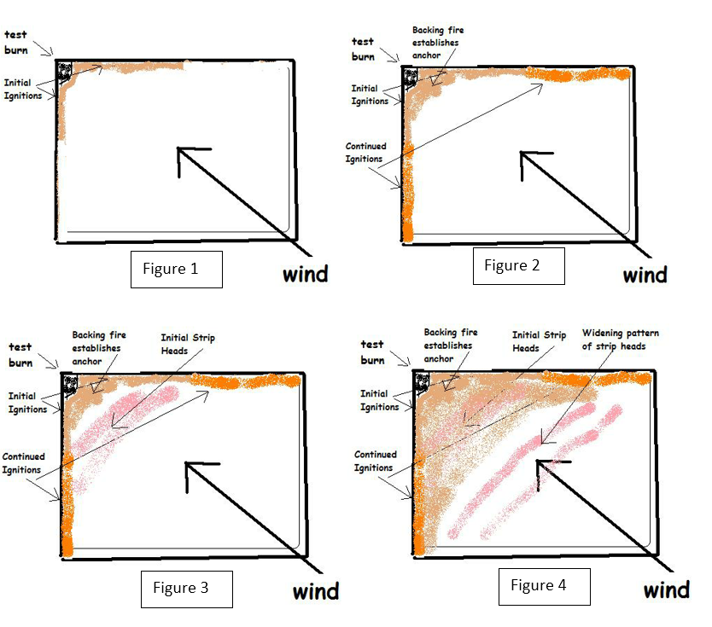

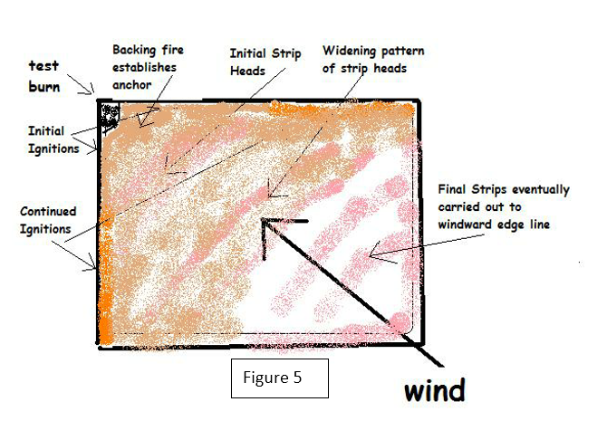

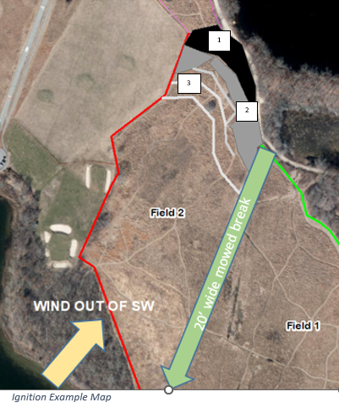
Test Burn: It is recommended that the initial backing fire and the subsequent first “strip head” fires described below in the Ignition Method section be used as a Test Burn to determine if weather conditions, fuels conditions and fire behavior will meet the established objectives and goals of the burn. The Burn Manager must evaluate whether the fire that is initially ignited is 1) likely to match the desired intensity of burning to meet resource goals and 2) decide whether the observed fire behavior is within the capabilities to be controlled by the on-site firefighter holding forces. If either of these questions are answered NO the Burn Manager should direct the fire be extinguished and re-evaluate whether to continue the burn when weather conditions change or to cancel burning for the day.
The ignition example map at right depicts how Field 2 might be burned using this method with winds out of the SW.
Ignition Method: Ignitions will commence on the extreme downwind edge of the burn block, preferably against a paved or gravel road or mowed and wet lined anchor point. The ignition source will be propane torch, cigarette lighter or preferably drip torch which can be used to light either spots or lines during ignitions. The fire will be lit at on the windward edge of the anchor point and be allowed to back against the wind into the planned burn area. On the Ignition Example Map this would be the black at #1 and expanding the backing fire in the gray area would be #2.
Ignition Pattern:
Once the burned out black anchor point zone is established through using backing fire in steps #1 and #2 we can then use narrow strip head fires to continue the burn. These head strips initially should only be 1-2’ wide. They will burn quickly as they “run” with the wind. The wider the downwind burned out black area becomes as more strip heads are applied, the wider we can make subsequent strips. See #3 on ignition example map. Once about 30 feet of black is established against the anchor point and carried up the flanks along the mowed breaks or other fuel breaks, these head strips can become much wider.
Strip head firing allows for quick consumption of the fuels, produces pulses of smoke rather than a smoke column, and allows for quick extinguishment in case of undesirable wind shifts.
Containment / Contingencies:
Firing will progress along the flanks, keeping the burnout along the flanks slightly ahead of the burning in the interior.
If winds shift the engines will use pump and roll to extinguish the single active strip head attacking from inside the black to reduce risks to firefighters. Pump and roll is where the engine is driving with the fire pump running and firefighters are walking alongside the engine using the booster hose reel to extinguish the base of the fire. Attacking from inside the black keeps both the fire engine and firefighters in the safety zone where the fuels have already burned out. Since all the vegetation has been burned off, the driver can also see holes, muddy spots or other hazards, however visibility may be compromised by smoke.
The burn area is completely surrounded by ample fire breaks consisting of one or more of the following: pond, closely-mowed firebreak or path, road, closely mowed driving range. Previous experience shows that fire will not bum closely mowed grass and self-extinguishes upon reaching this boundary when within the weather conditions described in this burn plans prescription.
There are two fire hydrants located adjacent to the burn unit. One hydrant (#36-Yellow with Red Top) is on the east side of Middle Farms Pond Road immediately across from the first homes driveway. The second hydrant (#37 – Red) is located along the extension of Middle Farms Pond Road in front of the Bob Miller homes.
Mop Up and Patrol:
Due to lack of density of fuel, all burns will self-extinguish within allotted burn time. Entire site wilI be checked by crew for smoke or hot spots before leaving and all hot spots will be thoroughly moped up. The Fire Department and crew will remain on site until all fires have been eliminated. The Burn Manager or designee will patrol the fire the next day to determine if the fire can be declared out, and will continue to patrol the burn daily until it has been so declared.
Safety plan:
The crew will be made up of fire suppression trained Fishers Island Fire Department members or other personnel who have had wildland fire suppression training. The crew will wear personal fire department issue turnout gear or other approved wildland fire personal protective equipment.
The Burn Manager or designee will monitor the weather on site during all phases of ignition to ensure the fire is in prescription. If the weather changes and goes out of prescription the burn manager may need to shut down all ignitions and extinguish the burn until conditions return to prescribed values.
The described firing techniques, ignition pattern and containment tactics enable firefighters to continually have a moving safety zone by always being in close proximity to “the black” where fire has already been and burned out.
In the event of serious injury, Fishers Island Ambulance will be contacted via radio. Crew will have golf cart or tractor for rapid transportation.

8-Suppression:

“A description of fire suppression activities to be immediately implemented should the prescribed burn threaten to escape, or actually escape, beyond the boundaries identified for such burn.” (Part 194.5)

In the event of a threatened or actual escaped fire the Burn Manager will size up the threats and call for additional Fishers Island Fire Department engines and resources as deemed necessary. It is noteworthy that the wooded areas west of the burn unit are all adjacent to Island Pond and even if fire entered the forests there they would be extinguished when hitting the shoreline of Island Pond. Also west of the burn unit is the golf driving range area which will not carry fire under the driest conditions and winds allowed in this prescription. To the east are woodlands modeled as TU2, a moderately flammable understory, but also surrounded by landscaped home grounds and open water. The North Field, 3 acres owned by the Ferguson Museum Land Trust is across East End Road to the west. It is a GR3 grass model, but if fire spotted into there it would likely be controlled by direct pump and roll tactics by the Fishers Island FD engines on scene. The prescribed wind directions make fire escape into that field highly improbable.

9-Notification:

“A description of the procedures for notifying appropriate department forest protection and fire management staff, local fire officials, law enforcement personnel and adjoining landowners of the actual date, time and estimated duration of any prescribed burn.” (Part 194.5)

10-Communications:

“A list of key communication contacts and telephone numbers.” (Part 194.5)

These elements are combined in this plan.
On site communications of fire ground resources will be accomplished by using Fishers Island FD mobile and portable radios.
Notification will be made on the morning of ignition by the Burn Manager (or designate) to the Southold Town Dispatch which dispatches both police and fire/rescue. 631-767-7600. This dispatch center is also available by mobile radio.
Additional Contacts:
- Emergency assistance and notifications Fire: Fishers Island Fire Dept. 631-788-7375
- Law enforcement: Local constables thru Southold Dispatch 631-767-7600
- Medical: Lawrence & Memorial Hospital, New London, CT via FIFD ambulance boat 631-788-7375
While 911 is always an emergency contact option, the geographic location of Fishers Island can lead to 911 calls linking to Connecticut emergency operations centers (EOC). For that reason the best number to use is the Southold Dispatch #631-767-7600 which ensures the call reaches the appropriate EOC.
Public information:
The Fishers Island Fire Department can ask that a Mass Notification Request (form in Appendix C) be issued the morning of a burn to Fishers Island residents from Suffolk County Fire Rescue (FRES) Duty Officer/Dispatcher. The Mass Notification Request is a reverse 911 call that broadcasts a message to telephones within the specified geographic area listed in the request form. There is no charge for this service, and FRES does these notifications for every prescribed burn conducted by NYS-DEC or other agencies within Suffolk County.

11-Smoke management:

“Identify potential smoke affected areas and smoke management strategies to avoid such areas, and to reduce and/or disperse emissions to minimize any adverse effect on the environment, including human health and welfare. Also note procedures for compliance with applicable State and local regulations.” (Part 194.5)

Potential smoke sensitive areas include the houses located east of burn area, Middle Farms Pond Road and East End Road. For the most part the prescribed wind directions preclude smoke from entering sensitive areas. The narrow strip head burning technique also ensures that smoke generated will be pulses, not a mass column. The minimal mixing height in the prescription ensures the smoke will lift and disperse rapidly.
In case of wind shift by using the narrow strip head technique the burning strip can be quickly suppressed. In addition these are very short burn events generally to be accomplished in less than 1 hour so smoke effect would be minimal. Burning when wind is from S or SW will not blow smoke in direction of houses.

12-Required signatures and approvals:

“The names and signature lines of the preparers of the prescribed fire plan, and for those who have the authority to review and approve the plan and modifications of the plan.” (Part 194.5)
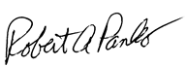

Prepared By: _____________________________________ (Signature) Date 08/20/2022_____
Robert A. Panko
NWCG Prescribed Burn Boss Type 2, Risky Business Incident Management LLC

Reviewed By: _____________________________________ (Signature) Date: _______________________
Jeff Edwards
Chief, Fishers Island Fire Department

Approved By: _____________________________________ (Signature) Date: _______________________
Pierce Rafferty
Henry L. Ferguson Museum Director

Approved By: _____________________________________ (Signature) Date: _______________________
John Wernet
NYS Dept. of Environmental Conservation
Region One Forester

References:
Weigand, Polly, “Coastal Maritime and Cool Season Grassland Management Recommendations for Henry L. Ferguson Museum and Land Trust Matty Matthiessen Wildlife Sanctuary & Grassland”; May 2012; United States Department of Agriculture Suffolk County Natural Resources Conservation Service and Suffolk County Soil and Water Conservation District
Joe H. Scott and Robert E. Burgan, “Standard Fire Behavior Fuel Models: A Comprehensive Set for Use with Rothermel’s Surface Fire Spread Model”, US Forest Service General Technical Report RMRS-GTR-153. June 2005

Appendices:

Appendix A – Fire Behavior Modeling

Appendix B – Fine Fuel Calculation Tables

Appendix C – Suffolk County FRES Mass Notification Request Form

APPENDIX A: Fire Behavior Modeling Results
Spring Burning Before Grass Green Up (March 1-May 12)
Modeling Runs Using Behave 6.0.0
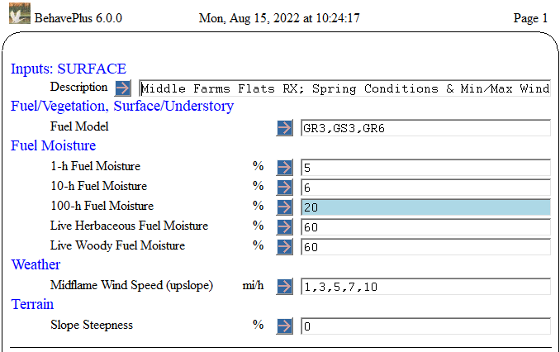
Using Driest Fuel Moistures and Wettest Fuel Moistures and Eye Level Winds 2-10 mph from Prescription
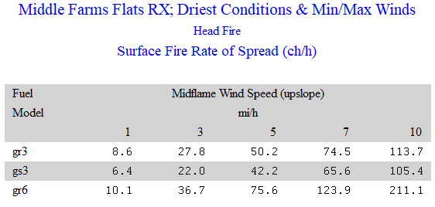
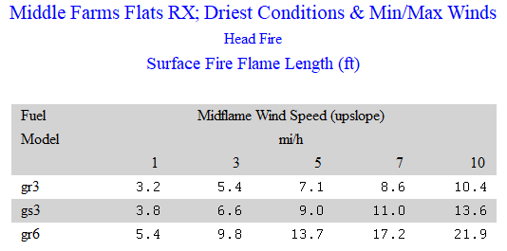
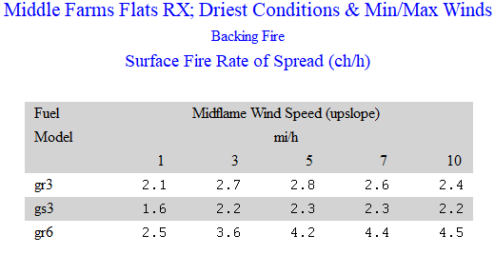
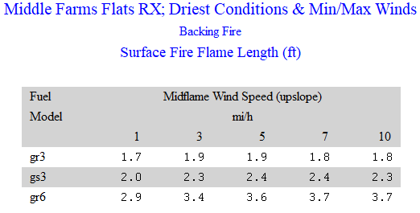
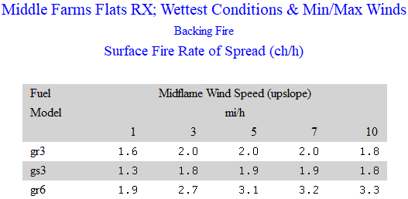
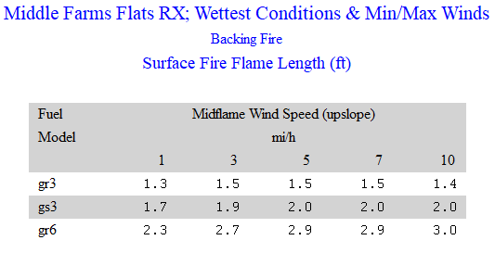
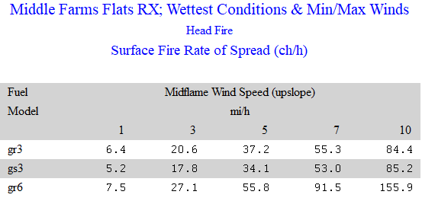
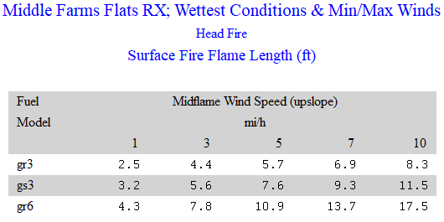
Fall Burning After Warm Season Grasses go Dormant (September-October)
Modeling Runs Using Behave 6.0.0
Based on Anticipated Optimal Conditions with 1 hr FM 7%, 10 hr. FM 12% and Live FM’s 100%

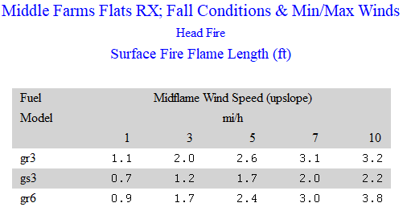
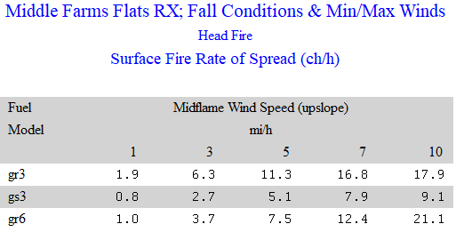
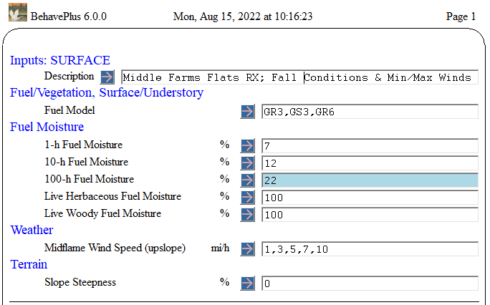

Probability of Ignition Caused by Fire Brand

Driest End of Prescription Wetter End of Prescription (but not the wettest)
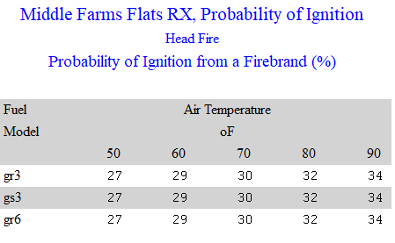
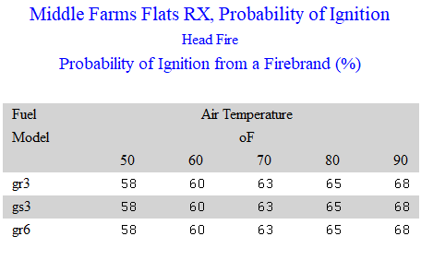
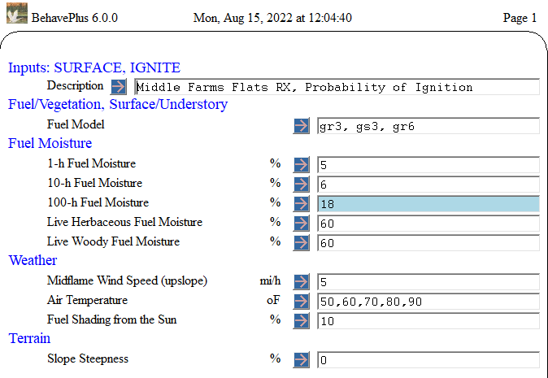
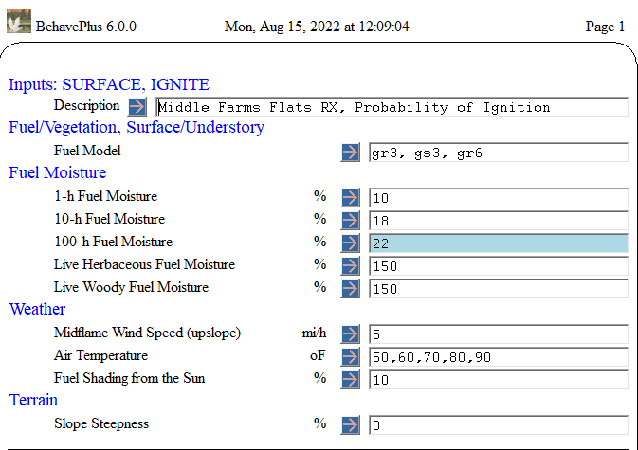

APPENDIX B: CALCULATING FINE FUEL MOISTURE

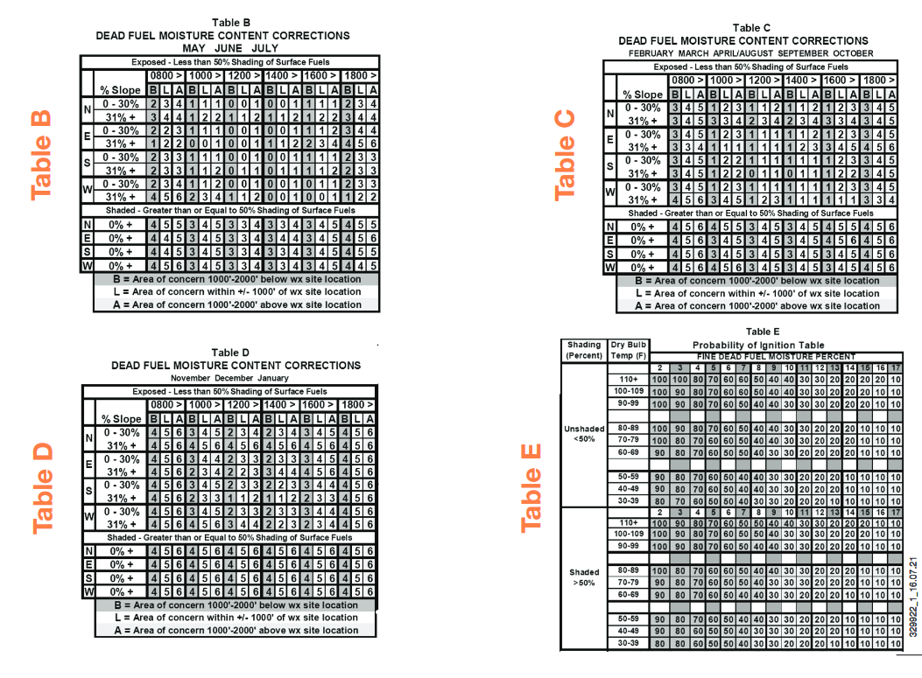

APPENDIX C: SUFFOLK COUNTY FIRE / RESCUE MASS NOTIFICATION REQUEST FORM
