APPENDIX A: Fire Behavior Modeling Results
Spring Burning Before Grass Green Up (March 1-May 12)
Modeling Runs Using Behave 6.0.0
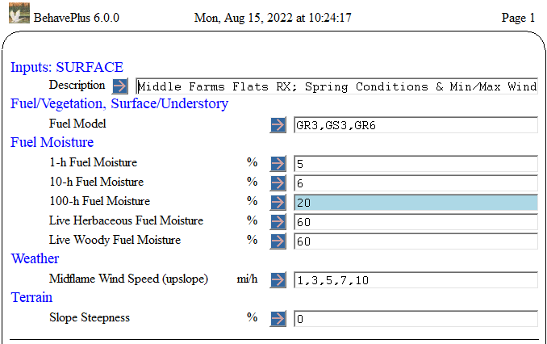
Using Driest Fuel Moistures and Wettest Fuel Moistures and Eye Level Winds 2-10 mph from Prescription
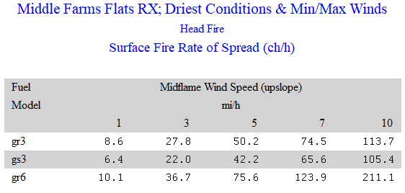
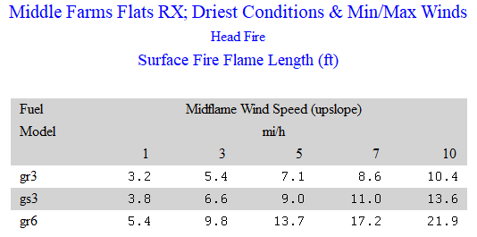
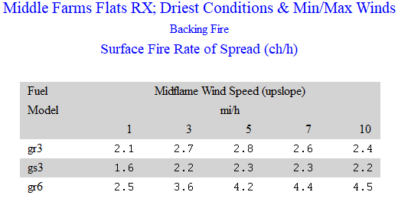
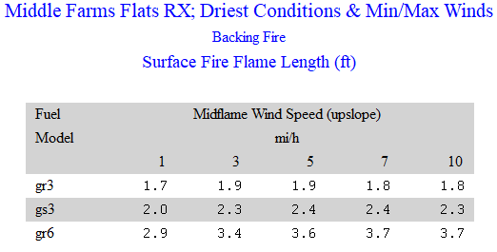
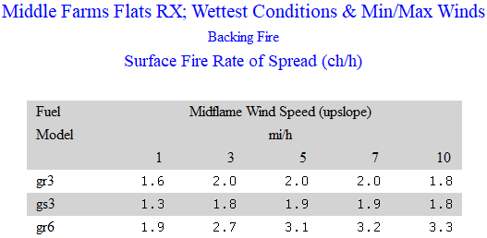
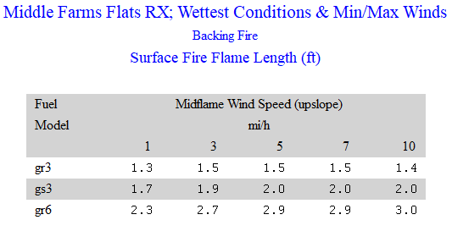
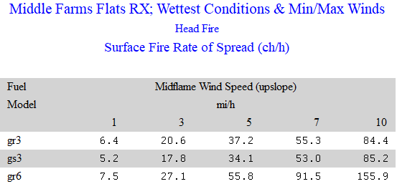
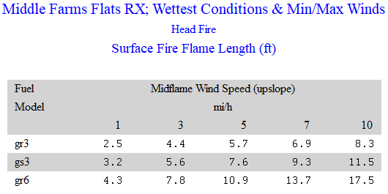
Fall Burning After Warm Season Grasses go Dormant (September-October)
Modeling Runs Using Behave 6.0.0
Based on Anticipated Optimal Conditions with 1 hr FM 7%, 10 hr. FM 12% and Live FM’s 100%

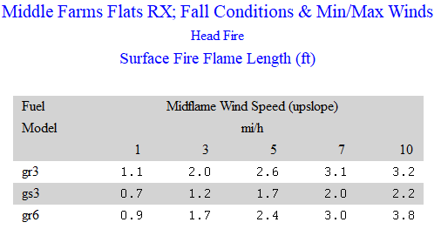
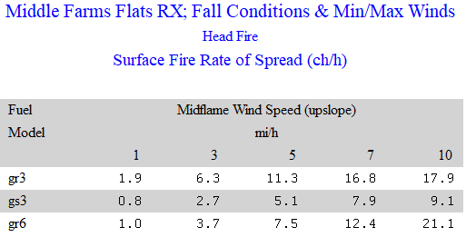
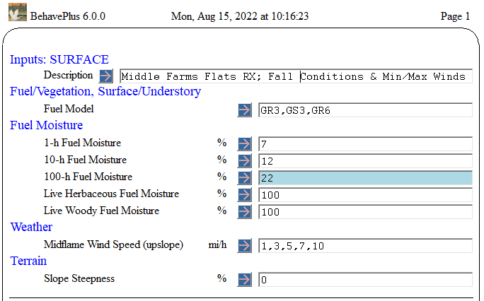

Probability of Ignition Caused by Fire Brand

Driest End of Prescription Wetter End of Prescription (but not the wettest)
