BURN DAY WEATHER CONDITIONS FOR MARCH 22, 2022 MIDDLE FARMS FLATS BURN UNIT FIELD 2
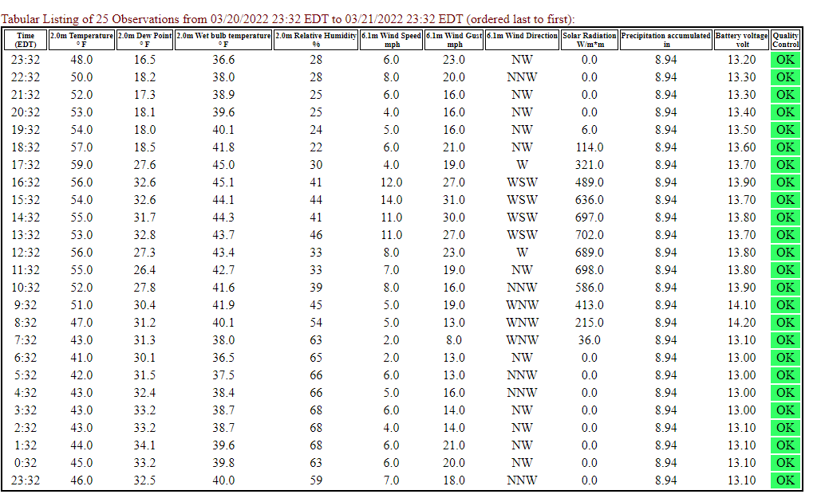
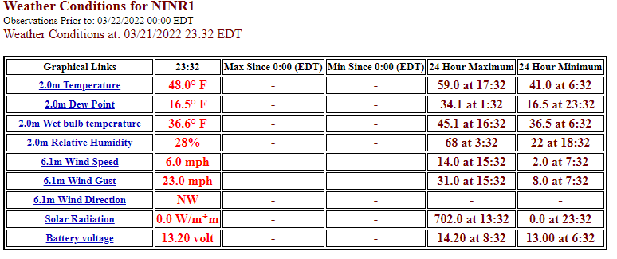
First Data is from the USFWS R

Private Weather Station at Edwards Lobsters, 5 Madeline Ave, Fishers Island
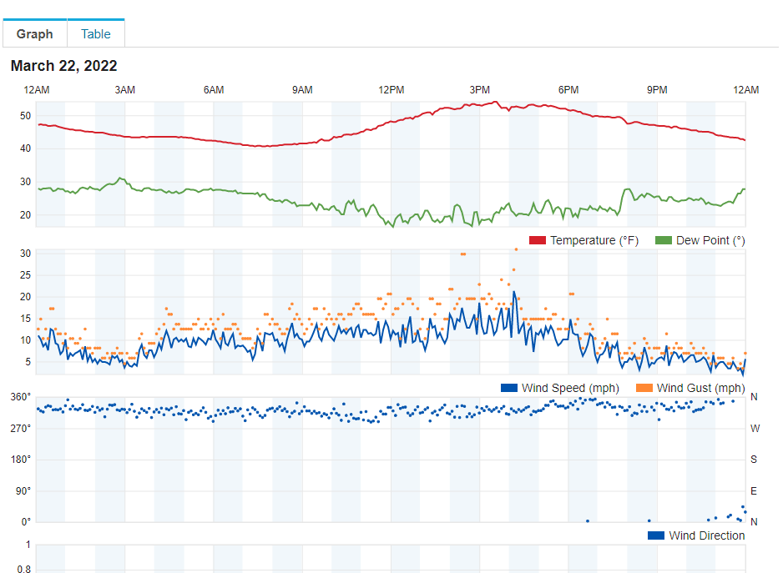
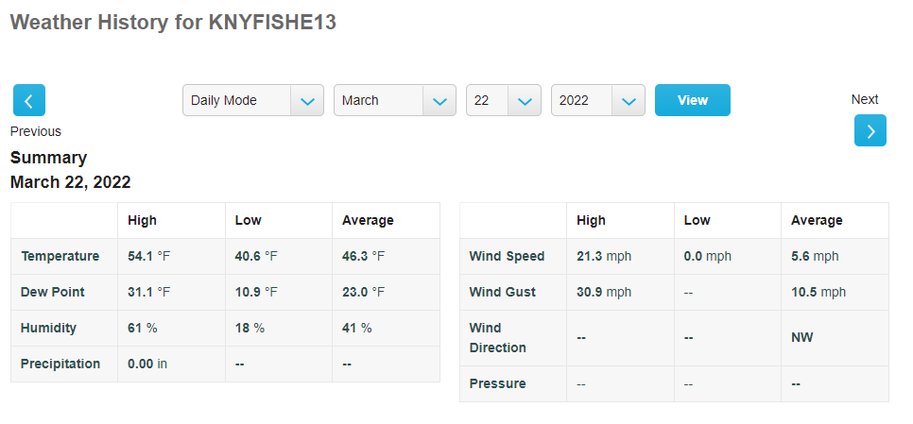
7X8P+QCR Fishers Island, New York

Private Weather Station KNYFISHE14 18073 E Main Rd (East End Road), Fishers Island, NY
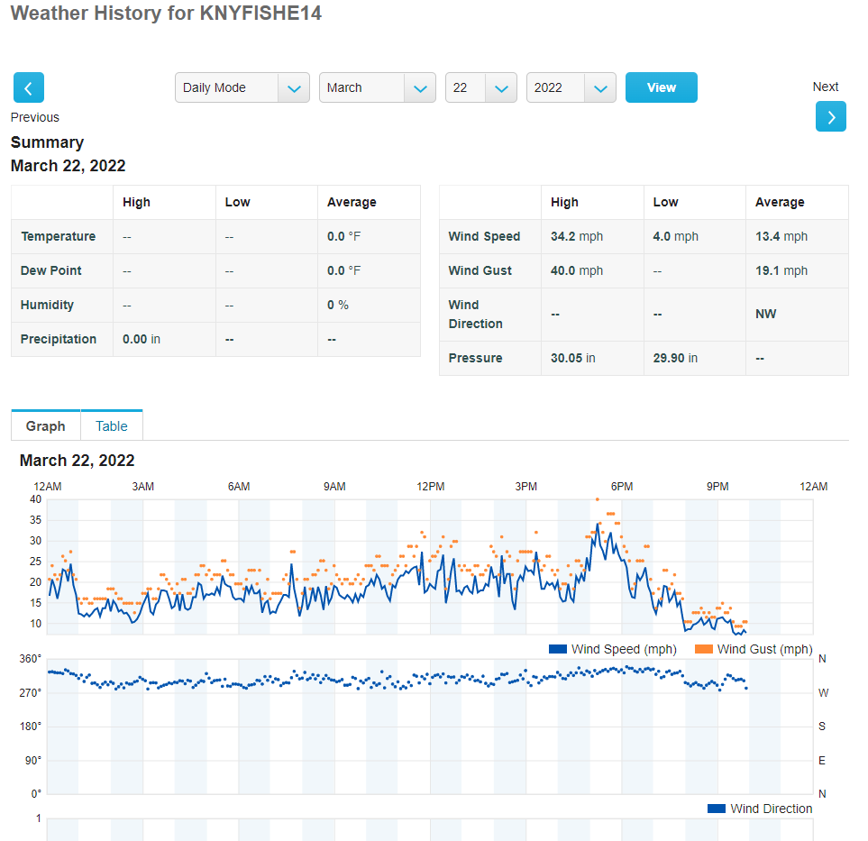
72JV+CH5 Fishers Island, New York

