

United States Department of the Interior

NATIONAL PARK SERVICE
National Capital Parks - East
Kenilworth Park and Aquatic Gardens
Washington, D.C. 20020

2014 Lotus & Water Lily Festival
Date: Saturday July 19
Time: 10:00 AM – 4:00 PM
Location: Kenilworth Aquatic Gardens & Park
Event Goals:
- Raise awareness about Kenilworth Aquatic Gardens and the park resources.
- To Showcase the water lilies and lotus’ from around the world that are grown in the garden.
- Provide a safe and enjoyable event for the public, exhibitors, staff and volunteers.
Event Synopsis:
The event is stages in 5 locations in the park to spread out activity across a wider area of the park so that large numbers of people can be accommodated. The “Welcome Zone” is the space for food vendors and exhibitors and art exhibits on the fence. The “Lotus Stage” is the main entertainment stage where performance type programming like dancing and music groups will perform. This area will also have the first aid tent since it is centrally located. The “Lily Stage is a smaller stage where educational programs will be hosted. “The Nature Tent” will be situated out along the edge of the ponds near the boardwalk. This tent will be interpretive and will be a place the public can ask questions and learn about the aquatic plants and the nearby habitats. “The activity zone” features hands-on activities like crafts, exhibitors and face painting.

Schedule:

6:30AM - 9:30 AM Management, support staff volunteers and participants arrive, event set-up, parking controls

9:30 AM Event briefing, uniform inspections, and other pre-event activities and information with park staff, participants and volunteers

10:00AM Gates open to visitors (official start of Festival)

4:00 PM Event concludes

4:00 PM – 6:00 PM Clean-up, break down and secure grounds

Contact numbers:
Eastern District Program Manager:
Julie Kutruff cell: 202-510-2423
KEAQ Gardener Supervisor/Volunteer Coordinator:
Douglas Rowley cell: 202-437-2142
KEAQ Supervisory Park Ranger/Event IC:
Walter McDowney cell: 301-535-6590

Event Layout: See attachment 1
Emergency Evacuation: Emergency Rally Points
In the event of emergency, there will be three (3) emergency rally points for concert staff and concert volunteers. All staff and volunteers must report to one of the designated rally points.
#1 Douglas Street Gate — Designated NPS Employee will rally at the Douglas Street Gate and take names of all employees, volunteers, participants and partners. Everyone working in the Stage area, visitors and participants will rally here.
- #2 Employee Parking Gate - Designated NPS Employee will rally at the Employee Parking Gate and take names of all employees, volunteers, participants and partners. Everyone working in around and behind the Visitor Center will rally at this point.
- #3 Main Parking Gate – Designated NPS Employee will rally at the Main Parking Gate and take names of all employees, volunteers, participants and partners. Everyone working in around and in front of the handicap entrance will rally at this point (Volunteer check in, maintenance staff and Lily Stage personnel)
Roll call lists will be submitted to NPS Event Supervisor. The event supervisor along with USPP will clear staff for departure after emergency events. All NPS Employees must contact Event Supervisor before departure from site.
Electrical Storms/Weather events: In the event of inclement weather event (ie., an electrical storm) the audience will be notified over the public address system to seek shelter from the storm. All sound equipment should be shut down during electrical storms. Festival staff and volunteers must move into a sheltered area during inclement weather events.
- Designated staff will monitor local weather forecasts and determine the likelihood of a weather event.
- Visitors should be evacuated at the earliest possible notice of imminent serious weather event.
Emergency Medical Services: Emergency Medical Response Services available during the festival include:
- EMT Contractor - 10:00 AM - 4:00 PM Contractor provides EMT service with minimum of 2 fully qualified EMT’s and equipment. The EMT staff will be stationed at the First Aid tent.
- USPP-Regularly scheduled United States’ Park Police officers who patrol the park on normal Saturday patrol will continue their role and functions. Park Police must be called for all emergencies on NPS radio or at 202-610-7500 Emergency or 202-610-7505 non-emergency.
- DC EMT/Police- 911 - Is called for emergencies as necessary. Any time 911 has been called USPP, Park Staff and on site EMT’s must also be notified.
- Be aware! Calling 911 will not notify USPP of the emergency. Metropolitan Police Department responds to 911 and will delay police response time.
Staff and volunteers should remain in contact with visitors reporting medical emergencies until USPP and EMT’s have responded to the scene.
Lost Person: The First Aid tent location will also serve as the lost person rendezvous point.
  - USPP will lead all lost person incidents. Event Supervisor and USPP will coordinate information and assignments for employees and volunteers during the situation.
  - In the event of a lost child, the gate and the Aquatic Gardens Parking Lot and the Welcome Zone Gate should be staffed and may be locked down temporarily until the child is located.
  - Parent/guardian looking for lost Child/Person
    - Keep Person with you. Do not let them walk away.
    - Notify USPP and event Supervisor.
    - Listen and remember any information/description the visitor can provide. Take notes with details to provide to USPP.
  - Child/Person can’t find Parent/Guardian.
    - Keep Child/Person with you.
    - Go directly to First Aid tent.
    - Notify USPP and Event Supervisor.
  - Park Staff will follow direction of USPP Supervisor in the event of lost person.

Communications: Radios are issued to the following positions. Additional radios will be issued to staff and volunteers as they are available
- Satellite Parking Coordinator
- Gardener Supervisor
- First aid tent EMTs issued 1 radio.
- Event Incident Commander
- Main/Handicap Gate station
- Employee Parking Gate station
- Douglas Street Gate station
- Visitor Center Facility Coordinator
- USPP Duty Sergeant
- Shuttle Buses
- Stage Coordinators
- Visitor Center
- Nature Tent
Lost and Found: The First Aid tent location will also serve as the lost and found.
  - Direct any visitors regarding lost and found items to the Ranger/First aid tent.
  - Record reports of lost property (description of item, name and contact info)
  - Please turn all lost and found items in a timely fashion to the First Aid Tent. At the end of the event, designated staff will secure all lost property.
Uniform: All NPS and Volunteer Staff members must wear the NPS prescribed uniforms throughout the event.
- NPS personnel are required to be dressed for roll call, uniform inspection and event briefing in a clean, free of stains, wrinkle-free summer uniform:
NPS service uniform for rangers (no cargo or field trousers)
NPS field uniform for maintenance/field employees
Required uniform components include the NPS badge, name tag, belt, brown socks and appropriate hat per uniform
Clean (free from dirt/mud) dark brown or cordovan shoes or boots
- Volunteers are required to wear the NPS volunteer T-shirt issued by NPS or shirt designed for event. Recommended clean, free of wrinkles and proper fitting khaki pants or jeans. Comfortable and clean closed toe shoes.
Additional equipment may be issued such as safety vests and radios.
Load In/Out:
Basic Park
Attachment 3 describes staff schedules and duties.
All NPS equipment is on site at the Visitor Center. Equipment will be set up and securely stored away on the day of the event.
Exhibitors Load in/out Exhibitors will arrive as early as 8:00 AM. They will be directed to the employee gate to unload and will be given one pass to park in the main parking area. Any additional vehicles will have to be parked in the satellite parking. They will be directed to their respective display locations where they will find their tables and chairs.
Parking for Rangers, Volunteers and Partners:
Parking for staff is available in the main/handicap parking lot as well as at satellite parking lots for those rangers working those areas. Exhibitors will be allowed one parking space in the main lot. All efforts should be made to arrive early to ensure parking access. Other parking options are legal street parking in the area but we would like to discourage such parking in order not to inundate the surrounding communities.
Public Parking: See attachment 2 (Satellite Parking map)
  - Parking in the Main parking lot begins early in the day with disabled visitors, participants (one space each) and volunteers and staff. Satellite parking is encouraged for all others with shuttle bus pick up to and from those areas until 5 PM.
Check out:
To allow for accurate accounting and personal safety all NPS Volunteers, staff and Partners must check out and return equipment to the Event Coordinator.
USPP Duty Sergeant should inform Park staff when clearing the grounds
Announcements and Music:
- Welcome remarks by Superintendent (or designee).
- Announcements over the sound system should be organized with the IC and will include activities and programs available during the festival, upcoming Park programs, community announcements and general Park advertisements and thank you to Park Supporters.
Event Logistics:
Event Logistics:
- Restrooms
  - 3 Regular and 2 handicapped units are located in the area of the main stage, close the trees on the south fence.
  - Restroom facilities are also available at the Visitor Center.
- Food and Souvenirs:
  - Food Truck Concessions are available at Anacostia Avenue and Douglas Streets. See attachment 1 for location of food vendor.
  - Souvenir sales, by Eastern National, are available near and inside the visitor Center.
- Picnic Tables
  - A limited number of Picnic Tables may be available on a first come first served basis. Visitors are allowed lawn chairs and picnic blankets in grassy areas.

- NPS Tent
  - Rangers engage visitors in informative question and answer periods about the flora and fauna and history of the park and surrounding area. Information is also distributed on the future plans for the area.
- Trash receptacles will be strategically located throughout the venue; staff should patrol the park, pass out trash bags to visitors and tend to all trash issues within their assigned zone. If assistance is needed with trash issues contact the designated IC.
  - Trash receptacles are emptied into dumpsters after the performance and secured. Volunteers remove the remaining trash on the morning following the event.
Recycling bins will be co-located with trash recepticles.
- Park Passport Stamps
  - Are located in the Visitor Center.

Attachments:
1: Lotus & Water Lily layout and Rally points
2: Satellite Parking and Shuttle Bus route
3: Staff assignments
4: Emergency contact information

Attachment 1 Event Layout Map
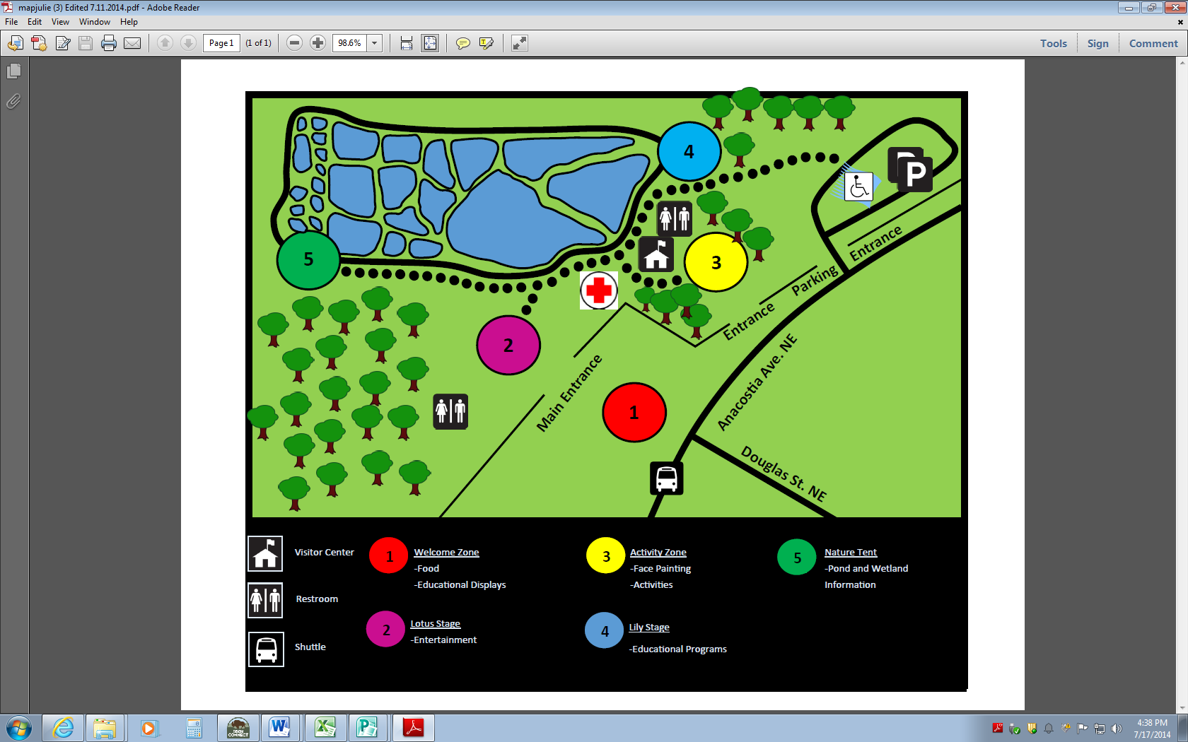

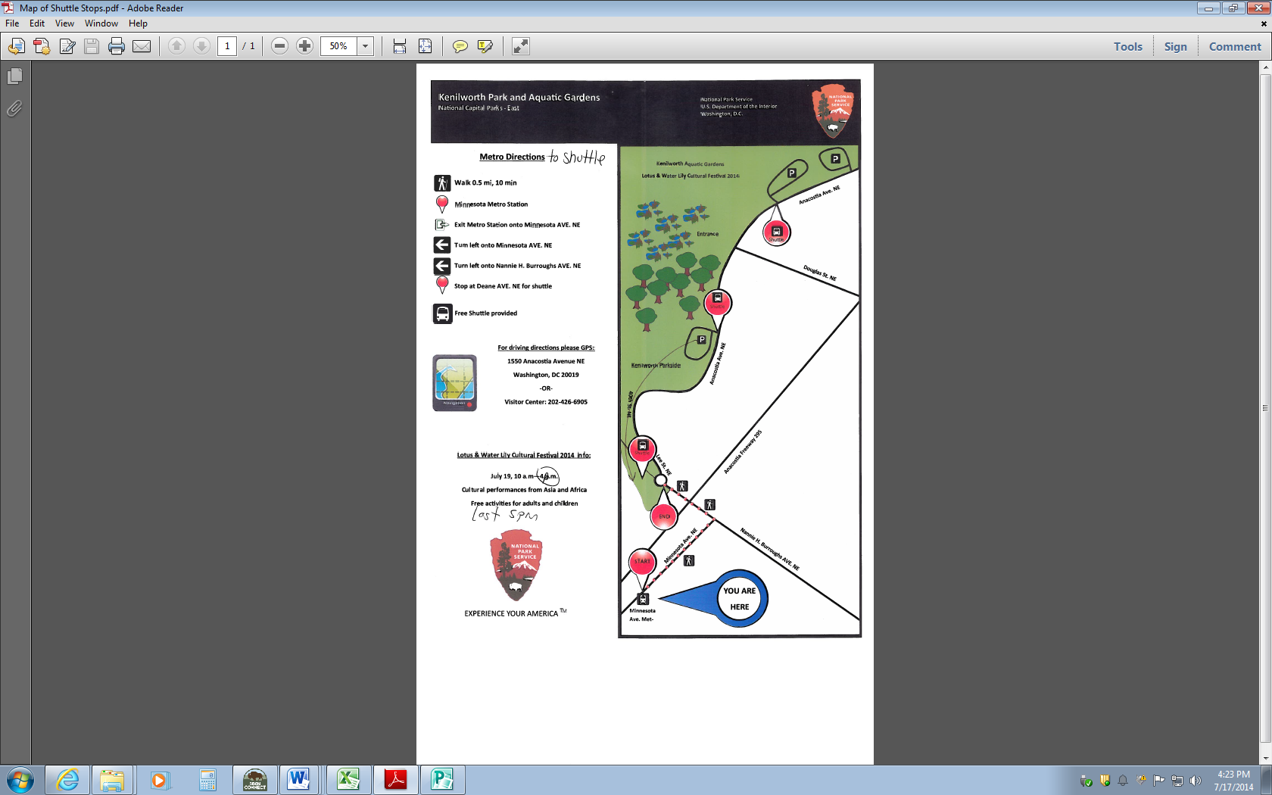
Attachment 2 Satellite Parking Map

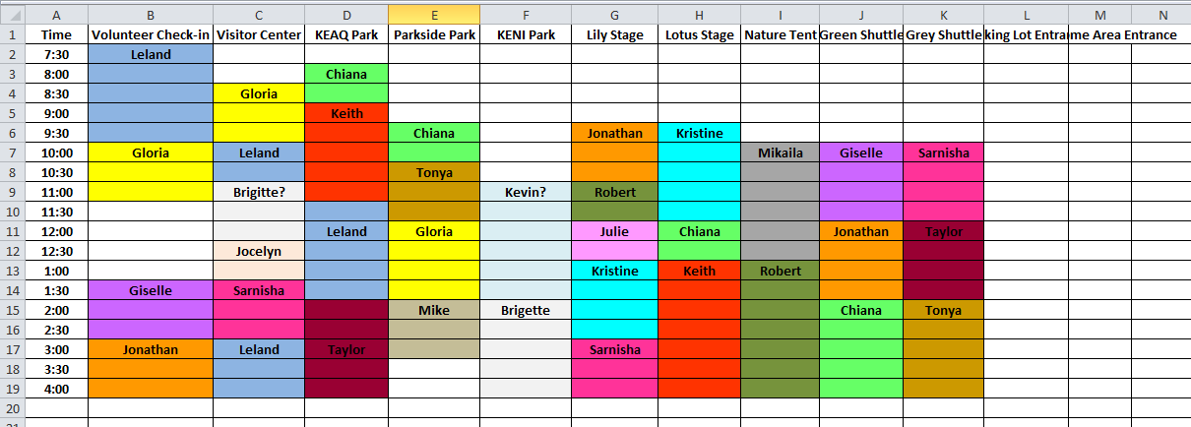
Attachment 3 Staff Assignments

Attachment 4 Emergency Contact Sheet
Emergency Contact Information

Emergency contact: Please fill out the below information, tear off the sheet and place it in your left shirt pocket. This will allow emergency responders to have access to any pertinent information in case of emergency.
Name:________________________________________
Home Park: ________________________________________
Emergency contact number: ________________________________________
Emergency contact name: ________________________________________
Relationship: ________________________________________
Allergies: ________________________________________
Current Medications: __________________________________________________________________________________________________________________________________________________________________________________________________________________________________________
Any pertinent information emergency responders should know: __________________________________________________________________________________________________________________________________________________________________________________________________________________________________________
Radio Use
Radio Use Cheat Sheet: Proper Radio Use, We will be using line of sight radios in most areas and a relay system when line of sight fells; use cell phones will be used as a back-up plan.
Example. When calling use the following format:
Caller: Main gate parking area, this is the Visitor Center
Reply: This is the Main Gate Parking area, go ahead: Commence conversation
NPS contract needs:
- Production Contractor- Contract arrangements should be made through the Eastern District Manager in January each year
- Portable toilets- 3 standard units and 2 accessible units
- Concessions- Park Concessions Specialist should arrange food and souvenir concession arrangements in the spring.
- Exhibitors and other participants should be contacted and confirmed by January
Facility Inspections / checks:
- The park, including trails & ponds, Visitor Center, and grounds of Kenilworth Aquatic Gardens should be inspected by Park Staff in early March, June, and July for major deficiencies.
- The Satellite Parking Areas should be identified and inspected during the early spring Months. Musk rat and beaver holes or wet areas may need to be repaired. Punch list of items to be addressed should be compiled and sent to appropriate divisions.
- Visitor Center Staff should inventory all supplies/materials from previous years and make ready for the next Festival. Use SCA, YCC, interns, and summer staff to prep supplies/materials.
Weekly checks and preparation: Festival season the following should be in order:
- Maintenance
  - Keep the park mowed and trimmed.
- Interpretation
  - Weekly topic for discussion organized prior to summer season.
  - Ranger Activities should be set up well in advance and fully prepared by the end of May.
  - Community Partners and other NPS displays/outreach should be finalized by the end of January.
  - Announcements to promote NPS activities and public information announcements should be prepared for this event.

